SECTION 28 31 00
FIRE ALARM AND DETECTION SYSTEMS

PART 1 – GENERAL [Design Professional shall amend specification section as required for each project]

1.1 WORK INCLUDES

A. Providing and installing an intelligent, fully addressable fire alarm and detection system.

B. Documentation and maintenance of equipment.

C. Testing system.

  - DRAWINGS

- The locations and spacing of alarm initiating devices indicated on the Drawings are approximate. The equipment supplier shall verify device requirements and spacing and shall add devices as required to satisfy governing authorities.

1.3 RELATED WORK [Enter Section #’s or delete as appropriate.]

A. Section [_____] - Door Hardware.

B. Section [_____] - Coiling Doors.

C. Section [_____] - Elevators.

D. Section [_____] - Fire Suppression System.

- Section [_____] - Smoke Dampers.

- Section [_____] - Sprinkler Systems.

- Section [_____] - Direct Digital Control System.

- Section [_____] – Emergency Responder Radio Coverage System (ERRCS).

- Smoke Control Systems.

- Air Duct Accessories.

- Division 26 - Electrical.

1.4 REFERENCES

- International Fire Code (IFC).

- ANSI/NFPA 72 - National Fire Alarm Code.

- Americans with Disabilities Act (ADA).

- ANSI/NFPA 13 - Installation of Sprinkler System.

- ANSI/NFPA 80 - Fire Doors and Fire Windows.

- Iowa Administrative Code.

- International Building Code (IBC).

- International Mechanical Code (IMC).

- University of Iowa Insurance Carrier - FM Global.

1.5 SPECIAL REQUIREMENTS
A. Contractor shall be responsible for any fees associated with the review and approval of the fire protection layout drawings and product data by the State Fire Marshal’s (SFM) office. Contractor shall also be responsible for completion of the required fire alarm system submittal form to the SFM. This form is available from the State at the following website: http://www.dps.state.ia.us/fm/building/forms.shtml.

[Confirm with PM and FM-Fire Safety Department or UI Housing and Dining if Article B is to be used when an existing fire alarm system is to be expanded. – If 10% of existing fire alarm system is impacted by project include Article B below.]

B. Contractor shall be responsible for the existing fire alarm system from the start of work until final completion of the fire alarm system including the monitoring of the system.

1.6 QUALITY ASSURANCE

A Manufacturer: Company specializing in alarm and detection systems with five years' experience in security alarms.

B. Provider: A company specializing in alarm and detection systems with five years documented experience in the installation and maintenance of fire alarm systems. The company shall process a valid State of Iowa Alarm Systems Contractor Certification, with a Registered Managing Employee (RME) having a fire alarm system endorsement (RME Endorsement 1)

- Installer: All alarm installers working for the provider company shall possess a valid state of Iowa alarm systems installer license for fire alarm systems (installer’s endorsement 1) and NICET II Certification. All electrical journeyman or masters electricians installing components (boxes, conduit, wiring, devices, etc.) for fire alarm systems shall possess a valid state of Iowa electrician’s license. Sub section 1. All state licensed electricians working under the provider must possess a valid alarm component installer endorsement (Endorsement 6)

D. Commissioning of a system or systems specified in this section is part of the construction process. Documentation and testing of these systems, as well as training of the Owner’s operation and maintenance personnel is required in cooperation with the Owner. Project closeout is dependent on successful completion of all commissioning procedures, documentation, and issue closure. Refer to Section 01 91 13, Commissioning, for detailed commissioning requirements.

E. Comply with ASME A17.1 and the State of Iowa Elevator Code for elevator operation.

1.7 SUBMITTALS

A. Shop Drawings: Shall consist of the following:
- Floor plans indicating the location of all fire alarm equipment and interconnection between devices. Fire alarm zone and device addresses shall be clearly labeled on the drawings.
- Quantities, types, and locations of all devices shown on the drawings shall be verified by the supplier and adjusted accordingly to meet NFPA, ADA and manufacturer's requirements.
2. Provide signal circuit #’s.
3. Provide field wiring diagrams (include wire colors).
4. Terminal connection diagram of the fire alarm control panel showing all wiring connection points.
5. Line diagrams
6. Number speaker and strobe devices in sequence of being pulled to.

B. Product Data: Provide data sheets for the following:
- Control panel.
- Initiating devices.
- Signaling devices.
- Control devices.
- Wire.
- Voice and tone communication system.

D. Manufacturer's Installation Instructions: Indicate installation instructions.

E. Manufacturer’s Certificate: Certify that system meets or exceeds specified requirements.

F. Submittals shall also include quantities of equipment, catalog cuts indicating technical data necessary to fully describe the equipment proposed.

G. Submittals shall be reviewed and approved by the State Fire Marshall's (SFM) office.

H. Submittals shall be approved by the Architect/Engineer and the Owner’s Fire Safety Department.

- Submittal drawings shall be on the job site for the creation of As-Built Drawings.

- Any proposed changes affecting the fire alarm systems must have the approval of the Owners Representative and the Fire Safety Department

- Where special installations may apply, refer to State Fire Marshal, UI insurance carrier or UI Department of Public Safety for additional requirements.

1.8 AS-BUILT DRAWINGS

A. Submit under the provisions of Section 01 78 39 As-Built Documents.

B. As-Built drawings shall be in compliance with NFPA 72 Completion Documentation, NFPA 72 Completion Forms, and check list (located on last page of this document) shall be provided to Owner’s Representative for distribution to FM-Fire Safety Department a minimum of 48 hours in advance of the partial or final inspection. As-Builts shall indicate the following:
- Alarm initiation devices with addresses.
- Alarm signal devices w/module location/address and circuit number.
- Door holder and smoke dampers with module location/address.
- Air handling units with module location/address.
- Junction and pull boxes.
- Layout of conduit.
- 120 VAC power source for control panel, door holders, and fire/smoke dampers.
- Location of all field device modules and “end of line resistors.”
- Calculations for voltage drop on circuits, battery and audio amplifier sizing.
- Contractor’s completed check list.

C. As-Builts shall be updated and re-submitted after all testing and check-out has been completed and accepted and shall include any corrections and/or changes made during final inspection.

1.9 OPERATION AND MAINTENANCE DATA

A. Submit under provisions of Section 01 78 23, Operation and Maintenance Data.

B. Operation Data: Include operational instructions including programmed data and sequence of operation.

C. Maintenance Data: Include maintenance and repair procedures, instructions, and data from installation.

D. Program Data: All data including factory and on-site programming.

1.10 COORDINATION

A. Contractor shall coordinate the installation of equipment and devices that pertain to the work of other trades with the appropriate Subcontractors.

- Fire alarm systems are very sensitive to strong chemicals, smoke, dust, heat, and moisture. Contractor shall use the Owner’s Contractor Request for Outage form as required for its work and shall notify the Owner’s Representative to advise FM-Fire Safety Department prior to any construction in areas where the fire alarm system is active. Owner’s Contractor Request for Outage form may be obtained from the following website: http://www.facilities.uiowa.edu/pdc/Contractors/ .

C. Software: Coordinate system programming with FM-Fire Safety Department. FM-Fire Safety Department shall have final approval of all walk test groups, zones, lists, custom controls, and address names.

- Contractor shall provide interim programming as required to accommodate partial building occupancy.

1.11 FIELD SERVICES

A. Contractor’s equipment supplier shall provide the services of a NICET II factory-trained representative who lives within a 125-mile radius of the University. The factory trained representative shall supervise the system installation and final connections to the equipment and provide testing to assure that the system is in proper operating condition.

1.12 SPARE PARTS [The Design Professional shall coordinate all spare part requirements with UI Fire Safety. Edit list as required per project.]

- Submit under the provisions of Section 01 77 19, Contract Closeout.

- Provide ten (10) percent or minimum one (1), whichever is greater, spare parts of the following devices to the Owner:
1. Heat and smoke detectors.
2. Detector bases
3. Pull stations
4. Control modules
5. Monitor modules
6. Audio Amplifier
7. A/V devices
8. ID Net Cards
9. Power Supplies
10. Specialty Systems: Duct Detectors, Aspirating Smoke Detection, etc.

1.13 WARRANTY

- All system components shall be warranted by the system manufacturer for a period of one year beginning at the time of substantial completion. During the warranty period, all defective components shall be replaced at no cost to the Owner. Refer to Section 00 72 13 General Conditions.

1.14 ACCEPTANCE TESTING

- Fire Alarm Contractor Pre-Test
- The electrical / alarm contractor shall conduct a hundred percent device check-out prior to owner’s inspection and provide a NFPA 72 Completion Form.
- For renovations, during the pre-test, the contractor shall reload the original software at the end of the day
- Audible sound level measurements shall be recorded throughout the entire building. Room/Area, Ambient Sound dBA, and Evacuation Sound dBA are the required documentation.

[The Design Professional shall include anticipated or actual ambient sound pressure levels for each Acoustically Distinguishable Space (ADS) as outlined in NFPA 72-2013 7.3.4.3.]

- The System must be capable of passing a voice intelligibility test for each Acoustically Distinguishable Spaces (ADS) indicated.

[The Design Professional shall clarify on the design documents which Acoustically Distinguishable Spaces] (ADS) are expected to achieve intelligibility (NFPA 72-2013 18.4.10.2).]

- Contractor’s tests shall be scheduled and documented in accordance with the commissioning requirements.

[The Design Professional shall coordinate final acceptance testing timeframe requirements with UI Fire Safety. Edit as required per project.]

- [One week] prior to final acceptance testing accurate as-built drawings showing the location of circuits, electrical sources, all addresses of equipment, end of line resistors, junction boxes, conduit locations, test stations, dampers, damper indicator lights., etc. Both Digital (AutoCAD .dwg file) and Hard copy shall be provided.

- To schedule the final checkout, the contractor shall present the following documentation to the owner's representative to be forwarded to the Fire Safety Shop:

- Completed and signed contractor check list, and NFPA 72 Completion Form.
- Written sequence of operation for the fire alarm system.
- Current software file.
- Any required spare parts.

- The contractor shall provide sufficient personnel to conduct the acceptance test.

- The manufacturers authorized representative shall perform a hundred percent quality inspection of the final installation and a complete test of all aspects of the system in the presence of the Contractor, Owners Representative, Fire Safety Department, any local code and fire authorities who want to supervise as well as the Architect, and Engineer.

- Documentation shall be submitted with Contractor’s Checklist of all devices tested/passed prior to final checkout being scheduled with UI Fire Safety.

PART 2 - PRODUCTS

2.1 FIRE ALARM CONTROL PANEL

- Fire alarm panel shall be an intelligent analog system with voice.
- Approved Manufacturers/Models:
- Basis of Design: [Select one basis of design (i or ii) and delete the other. This includes Drawings A, B, & C at the end of this specification – Delete drawings not applicable]
- Simplex 4100ES w/voice – See Drawings A, B & C
- Notifier 3030 – See Drawings A, B & C [Use for UI Housing and Dining projects or as directed by UI Fire Safety.]
- No other substitutions will be allowed.

- Fire alarm signal initiation shall be by one or more of the following devices as required:
      - Manual stations.
      - Heat detectors.
      - Flame detectors.
      - Smoke detectors or aspirated device.
      - Verified automatic alarm operation of smoke detectors.
      - Automatic sprinkler system water flow.
      - Fire extinguishing system operation.

- Fire alarm signal shall initiate the following actions:
          - Alarm notification devices shall operate continuously.
          - Identify alarm at the fire alarm control panel (FACP) and remote annunciators.
          - Transmit an alarm signal to the remote alarm receiving station.
          - Unlock electric door locks in designated egress paths.
          - Release fire and smoke doors held open if a detector adjacent to the door is in alarm.
          - Activate voice/alarm communication system.
          - Shut down fans and other air-handling equipment serving zone where alarm was initiated.
          - Shut down fans and other air-handling equipment throughout the building.
          - Initiate smoke control sequences.
          - Close smoke dampers in air ducts of system serving zone where alarm was initiated.
          - Recall elevators if the alarm is initiated by a detector located in an associated machine room, hoist way, or elevator lobby.
          - Record events in the system memory.

- Supervisory signal initiation shall be by one or more of the following devices or actions:
1. Operation of a fire-protection system valve tamper.
2. Duct Detector Activation

- System trouble signal initiation shall be by one or more of the following devices or actions as required:
- Open circuits, shorts, and grounds of wiring for initiating device, signaling line, and notification-device circuits.
- Opening, tampering, or removal of alarm-initiating and supervisory signal-initiating devices.
- Loss of primary power at the FACP.
- Ground or a single break in FACP internal circuits.
- Abnormal ac voltage at the FACP.
- A break in standby battery circuitry.
- Failure of battery charging.
- Abnormal position of any switch at the FACP or annunciator.
- Fire-pump power failure, including a dead-phase or phase-reversal condition.
- Low-air-pressure switch operation on a dry-pipe or pre-action sprinkler system.
- All power disconnect switches for both the jockey pump and fire pump shall be monitored.

- System Trouble and Supervisory Signal Actions: Sound appropriate signal and annunciate at the FACP and remote annunciates, Transmit the appropriate signal to the remote alarm receiving station.

- Circuits: [Modify only if other wiring required by FM-Fire Safety Department, UI insurance carrier and/or Authority Having Jurisdiction.]
1. Signaling Line Circuits (SLC): NFPA 72, Class B, Style 4.
2. Notification Device Circuits: Class B, Style Y.

- Provide all hardware devices and software for off-line programming, complete with manuals and software files, to the Owner Representative.

- Battery Back-up: Capable of supplying a minimum of 24 hours of operation in normal condition followed by no less than 15 minutes of alarm. Verify longer times for high risk building areas, pre-action systems or if used for releasing agent panels.

- All circuits shall have the capability of handling a minimum of twenty percent more equipment.

- A separate SLC circuit shall be installed per floor.

- Provide dedicated audio circuit for exterior devices.

- Central FACP:
          - Cabinet: Lockable steel enclosure.
a. Arrange interior components so operations required for testing or for normal maintenance of the system are performed from the front of the enclosure. If more than one unit is required to form a complete control panel, fabricate with matching modular unit enclosure to accommodate components and to allow ample gutter space for field wiring and interconnecting panels.
b. Arrange exterior components to meet safe working clearances allowing a minimum of 6 inches between cabinets and wall space should allow for growth/expansion for to electronic technologies, i.e. networking.
          - Mounting: [Semi-flush or Surface – select one]
          - Keys: Common to all system components
          - All devices/equipment shall be mounted to the panel with proper attachment devise.

- The building main FACP shall not be used as a releasing panel. For releasing panels use a Simplex 4100ES REL panel as an additional panel to the main building FACP.

      - Releasing panels shall have unique audio signals / visual devices from building FACP. Releasing panels shall include delay releasing agent switches, phone line available for use near abort switches.
      - The releasing panel shall follow FM Global standards.

- FACP Bypass Switches:
(Access Level 3)
1. City disconnect (For both alarms & troubles)
2. Audio by-pass
3. Visual circuit by-pass
4. Electronic door latches/locks
5. Air handler by-pass
(Access Level 1)
6. Dampers by-pass
7. Elevator by-pass
8. Fire Door by-pass
9. Provide separate fan shutdown switches for each air handler.
10. Smoke purge by-pass [Where applicable – delete item 10 if not applicable]

- Voice Control Point Switches:
1. "All Clear" message.
2. "Weather Alert" message
3. "All speakers" talk switch.
4. Audio zone momentary contact switches to manually select the following individual speaker circuits:
a. Each stairwell separately.
b. Each building level and approved fire zone.
c. Outside speakers.

- LED Lights:
1. Only fire alarm zone lights and "device type" lights shall annunciate with a red LED. Device type, address and exact location shall annunciate on the digital readout.
2. Any by-pass, disable, or trouble condition shall annunciate with an amber LED, a trouble sounder and annunciate on the digital readout.
3. When speakers or phone circuits are active, green LEDs shall annunciate the appropriate speaker circuits. Individual speaker circuits shall be capable of being activated without a pass code even if the panel is not in the alarm condition. Individual speaker control shall be possible with loss of A/C power.

- Voice/Tone Speakers:
1. Low-Range Units: Rated 1/4 to 2 W.
2. UL 1480 listed
2. Size:
            - Ceiling-Mounted Speakers: 8 inch.
            - Wall-Mounted speakers: 4 inch.
3. Mounting:
- Ceiling: Flush with white baffle.
- Wall: [Semi-recessed or Surface] with [red or white] housing and/or skirt.
Include back box for speakers which do not mount over a standard 4 inch junction box.

- System Resets:
1. A fire alarm reset shall require a security level access level of 3.
2. Equipment that has been by-passed in software shall not change state of condition during a “reset”

2.2 PHOTO-ELECTRIC SMOKE DETECTORS

- Photo-electric detectors shall provide a solid red LED on the detector or base when the device is in the alarm condition.

- Smoke detectors shall be analog addressable, low profile.

- UL 268 listed.

- Individual dormitory hotel apartment sleeping room smoke detector [only to be used if sleeping rooms; omit entire item D for all other projects]:
          - Type: Photoelectric.
          - Mounting: Low profile addressable base with low frequency sounder.
          - Alarm Set point: Preset.
          - LED status indicator.
          - Local strobe.
          - Operation: Alarm condition sounds individual room alarm including all rooms in each suite, sounds alarm at control panel, displays readout at annunciator panel. Alarm shall not activate building signaling appliance. Follow all ADA and Low Frequency NFPA Codes.

2.3 HEAT DETECTORS

- Heat detectors shall be restorable and provide a red LED on the detector or base when the device is in the alarm condition.

- Heat detectors shall be analog addressable rate-of rise and fixed temperature unless they are high temperature devices.

- UL 521 Listed.

2.4 ALTERNATE DETECTION DEVICES [The Design Professional shall provide additional equipment requirements and installation requirements for these devices when they are used. Coordinate use with UI Fire Safety.]

- Beam Detectors
- All beam detectors shall have a transmitter and a mirror. (No receiver.)
2. All beam detectors shall have a key or magnet test station.

- Aspirating smoke detector (ASD) system:
- Provide any software, test equipment and training as required for product.
- All sampling tubes shall have a test location that is located near device and be at readily accessible location.
- All sampling ports shall be visible or marked for port locations.

2.5 DUCT DETECTORS [The Design Professional shall verify test switch requirements with UI Fire Safety and UI Housing and Dining. Remote test switches are required for UI Housing and Dining. Remote test switches are not required for non-UI Housing and Dining projects unless directed by UI Fire Safety.]

- Duct detectors must be installed when they meet the conditions listed in the International Mechanical Code.

- Each duct detector shall be provided with labeled red LED indicating light. Indicating light may be wall or ceiling mounted in direct vicinity of the duct detector.

- UL 268A listed.

- Duct smoke detectors shall be used only in ducts 6 inch or larger in diameter.

- Remote test switches [are/are not] required.

2.6 DOOR AND SHUTTER RELEASE

- Electronic door hold-opens shall be 24 volt DC power.

- Electronic door hold-opens with built-in smoke detectors will not be accepted.

- Door hold opens shall not close on loss of power to the FACP. Power for door hold opens shall not be from FACP or components.

- All rolling fire doors / shutters doors controlled by the FACP shall be motorized units with key reset at readily accessible location (motorized: open and closed).

[The Design Professional shall coordinate door hold open devices with Door Hardware. Delete if devices are being provided by Door Hardware.]

- Units shall be equipped for wall or floor mounting as indicated and are complete with matching door plate.
1. Electromagnet: Requires no more than 3 W to develop 25 lbs. holding force.
2. Wall-Mounted Units: Surface mounted, unless otherwise indicated.
3. Contact Plate: Adjustable.

2.7 COMMUNICATORS [FIBER AND TELEPHONE]
[Design Professional shall coordinate these requirements with the Division 27 designer, UI Fire Safety, and UI Housing and Dining. Simplex systems require fiber connection. Notifier systems require analog telecommunications. Select systems may require both.]

- Provide DACT compatible with [single mode fiber connections and analog telecommunications].

2.8 EMERGENCY RESPONDER RADIO COVERAGE SYSTEM – IN BUILDING
- Provide monitoring of Emergency Responder Radio Coverage System (ERRCS) in compliance with the International Fire Code.

  - REMOTE ANNUNCIATOR [Use only when required by UI Fire Safety or Authority Having Jurisdiction]

        - The remote annunciator shall have duplicate annunciator functions of the FACP for alarm, supervisory, and trouble indications and shall have duplicate manual switching functions of the FACP, including acknowledging, and silencing, reset, and test which should be under Level 4 access only.

        - The remote annunciator shall be installed in a lockable steel enclosure keyed to match FACP.
1. Mounting: Flush cabinet, NEMA 250, Class 1.

        - Display Type and Functional Performance: Alphanumeric display same as the FACP. Controls with associated LEDs permit acknowledging, silencing, resetting, and testing functions for alarm, supervisory, and trouble signals identical to those in the FACP.

2.10 PULL STATIONS

        - Pull stations shall be finished in red with molded, raised-letter operating instructions of contrasting color.
1. Double-action mechanism initiates an alarm.
2. Station Reset: Key; double pole, double throw; switch rated for the voltage and current at which it operates.

        - All pull stations shall be addressable.

        - Pull stations shall be located at all exits, each stair level, and large machine rooms.

2.11 SPRINKLER HORN/STROBE

- Provide Potter Sash-24 #1000055 Sprinkler Siren/Strobe. See Drawing A for details.

- Locate this device directly above the fire department sprinkler connection on the exterior of the building.

- Sprinkler horn/strobe circuits shall be home run to the FACP for power, or the nearest NAC panel.
[Exception: Fire Safety Department written approval of control module and relay installation to operate it.]

2.12 AUDIO SYSTEM

- Amplifiers shall be a minimum size of 100 W amplifiers shall have redundant back-up amplifier(s) that automatically transfer. [Exceptions: Written approval by Fire Safety Shop.] They shall be sized using calculations of:
1. One (1) W per interior speaker
2. Two (2) W per outside and mechanical room speaker.
3. Each audio amplifier shall be sized to include 20 percent spare capacity for future connection of audio speakers.
4. Sound must reach 15 dBA above average ambient sound level or 5dBA above maximum sound levels, whichever is greater, per code.

2.13 VISUAL INDICATORS

- Strobe intensity shall be determined by NFPA 72 requirements.

- All strobes within site shall be synchronized.

- Each strobe circuit shall be capable of being individually controlled in software.

- Smoke damper indicator lights:
1. Use only SELECT-A-SWITCH, Model SL53413-6-BG.
[Exception can be issued in writing by UI Housing and Dining for Indicator Lights at FACP]

2.14 BACK BOXES

  - Finished back boxes shall be provided by equipment supplier for any surface-mounted pull stations or signaling devices.

2.15 EMERGENCY POWER SUPPLY

  - Battery Capacity: Comply with NFPA 72 for a system operating without a backup generator.

2.16 ADDRESSABLE INTERFACE DEVICES

- Monitor Module: Microelectronic module listed for use in providing a multiplex system address for listed fire and sprinkler alarm-initiating devices with normally open contacts; allows individual monitoring of non-addressable points.

- Control Module: Microelectronic module listed for use in providing a multiplex system address to relays for system control functions.
  - Relay: 24 VDC coil; contacts rated 10A, 115 VAC, minimum; suitable for control function required. Fire Rated RIB Relays Only.

2.17 GUARDS FOR PHYSICAL PROTECTION [IF REQUIRED – Design Professional shall delete this article if not required by Project]

- Guards shall bewelded wire mesh of size and shape for the manual station, smoke detector, gong, or other device requiring protection.
- Factory fabricated and furnished by the manufacturer of the device.
- Finish: White epoxy powder coat.

PART 3 – EXECUTION

3.1 GENERAL

- Contractor shall verify that Coordination Drawings have been approved and signed by all participating contractors.

- Install the fire alarm system in accordance with approved manufacturer’s wiring diagrams. Furnish all conduit, wiring, outlet boxes, junction boxes, cabinets, and similar devices necessary for a complete installation. Boxes shall be installed in accessible spaces without requiring the removal of light fixtures or any other equipment.

- Coordinate the installation of equipment and devices that pertain to the work of other trades with the appropriate contractors.

- Submittal drawings shall be on the job site for the creation of As-Built Drawings.

- Any proposed changes affecting the fire alarm systems must have the approval of the Owner’s Representative and the Fire Safety Department

3.2 MANDATORY CONTRACTOR TRAINING [Delete section for UI Housing and Dining Projects]

- Prior to fire alarm installation, all contractor personnel directly involved with supervision and/or installation of the fire alarm system shall attend a one (1) hour training provided by FM-Fire Safety maintenance personnel. Contractors may schedule training by calling FM-Fire Safety at 319-335-5125 or email fm-fire-safety-scheduling@uiowa.edu.

- No Sprinkler System or Fire Alarm system shutdowns or disables shall be completed until mandatory contractor training has occurred.

3.3 ELECTRICAL REQUIREMENTS

- Wiring method: Install wiring in raceway according to Division 26. Conceal raceway except in unfinished spaces as indicated.
Wiring Size and Color Standard shall be as follows:

 | AWG Wire Size | Wire Color (+) | Wire Color (-)
Loop/ID net (SLC)  -Special cable approved by equipment supplier | #18  Plenum | Red | Black
Speakers (Typ. inside office buildings)  -Special cable approved by equipment supplier | #16  Shielded  Plenum | Red | Black
Horns (Typ. inside industrial plants) | #14  Jacketed | Red | Black
Module Power* | #14 | Violet | Blue
Re-settable Module Power* | #14 | Yellow | Gray
Strobe Circuits | #14 | Red | Black
Door Holder | #14 | Brown | White
* Must be supervised for power loss at each device

- When conventional wiring is used, it shall be solid, THHN.

- Line voltage (120VAC) shall be run in separate conduit.

- Wiring within Enclosures: Install separate power-limited and non-power-limited conductors as recommended by the manufacturer. Install conductors parallel with or at right angles to sides and back of the enclosure. Bundle, lace, and train conductors to terminal points with no excess. Connect conductors that are terminated, spliced, or interrupted in any enclosure associated with the fire alarm system to terminal blocks. Mark each terminal according to the system's wiring diagrams. Make all connections with approved crimp-on terminal spade lugs, pressure-type terminal blocks, or plug connectors.

- All rolling fire doors / shutters doors controlled by the FACP shall be motorized (open and close) units and must be switch resettable. (No Firefly type release accepted)

- Provide locking breaker on 120 VAC power source and label "Fire Alarm." Locking breaker shall be painted red. Any power source to FACP or devices shall be labeled with location of Power source for room number, panel, and circuit number.

- Fire alarm control and remote power panel’s power shall be supplied by a surge protected dedicated circuit(s).

- A PS20AC1 switch shall be installed within the fire alarm control panel to disconnect 120 volt power and another PS20AC1 switch shall be installed within the fire alarm control panel to disconnect all battery power.

- No spare conductors shall be in conduit or junction boxes.

- Electrical (non-rubber) tape shall be used to insulate all grounding shields.

- All junction and pull boxes shall be a minimum size of 4-11/16 inch square by 2-1/8 inch deep.

- No octagon boxes or box extensions shall be permitted on new work.

- All fire alarm devices, junction and pull boxes shall be installed so they are easily accessible without removing light fixtures, equipment, conduits, junction boxes or other items.

- No splicing will be allowed in device mounting boxes.

- "End of Line Resistors" shall be located at the device that is farthest away from the panel or module.

- All devices being controlled by the fire alarm control panel (i.e., dampers, doors, rolling shutters, etc.) shall be operated using control modules and not by relay type devices in detector bases or relay cards. No auxiliary equipment shall be directly connected to an addressable control module. 24V dc power must be supervised at each device. Each control module shall activate a supervised 24V dc relay with red LED when in the “alarm” state.

- Each floor shall have a separate riser conduit feed.

- All fire alarm system conduits shall be red. Exposed conduit is finished spaces may be painted to match wall or ceiling. No conduit is to be installed in floors. Any deviations shall be discussed with UI Construction Manager and UI Fire Safety.

- Auxiliary functions that are powered from a remote source must be monitored for power if they do not go to the operational mode for fire protection. (I.e. A power opener purge door that must open to purge air through building or a stairway air pressurization fan that must be monitored for power in case the breaker is shut off.)

- Ground cable shields and equipment according to system manufacturer's written instructions to eliminate shock hazard and to minimize, to the greatest extent possible, ground loops, common-mode returns, noise pickup, cross talk, and other impairments.

- Fire Protection System:
- Connect all sprinkler system flow detection devices and tamper switches, including post or wall indicator valves. Provide an addressable interface module for each device.
- Provide RGS conduit where exposed at post or wall indicator valve.
- Connect fire pump run contacts. Fire pump running shall be annunciated on the fire alarm system as “Fire Pump Running”.
- Connect fire pump and jockey pump trouble contacts. Fire pump alarms shall be annunciated on the fire alarm system as “Fire Pump Trouble”.
- Power loss shall be programmed as a supervisory point

INTERCONNECTION TO OTHER SYSTEMS [Design Professional shall coordinate the cabling and pathway requirements to nearest telecom closet with the Division 27 designer, UI Fire Safety, and UI Housing and Dining. Select options below as required.]

- Communication to fire alarm system shall be a 6-strand 28E Grade (8.3/125 Micron) fiber cable.

- Communication to fire alarm system shall be two copper telephone lines. The two lines shall be installed to the main panel with SC termination boxes. User RJ45 for copper, RJ 31x Jacks for boxes.

3.5 FIRE CONTROL PANEL INSTALLATION

- Install the system in accordance with manufacturer's instructions.

- Fire alarm control panel cabinets shall be mounted at 6 foot to the top of the cabinet. There shall be a minimum of 6 inch spacing between cabinets. A minimum of 6 foot clear wall space is required for panels. (No other equipment shall be installed in this 6 foot area.) 3 foot clearance in front of open doors and panel doors shall be able to open fully. Do not mount in vestibules or stairwell areas.

- Panel door locks shall be front mounted.

- Telephone Communicator
1. Shall send the following signals to the University of Iowa Police Dispatch Office.
a. Alarms (Zone 1)
b. Troubles (Zone 3)
c. Supervisory (Zone 4)
2. The DACT trouble signal shall track the FACP trouble piezo.
3. The electrical contractor shall provide a ¾ inch conduit with pull string from the fire alarm control panel to designated telephone switch room.

- The fire panel shall be capable of networking fully addressable information to the Simplex fire alarm network.

- Trim out FACP per Contract requirements.

- Maintain panel dust-free during construction.

3.6 DEVICE INSTALLATION

        - Initiating Devices:
1. Smoke Detectors:
            - Cover all smoke detection devices immediately after installation to maintain cleanliness. All devices shall be in like new condition for final acceptance.
            - Install within five feet of each door held open by the fire alarm system.
            - Where adjacent to an air shaft, supply diffuser or return grille, install smoke detector 36 inches minimum from the edge of the diffuser or grill.
            - Provide a smoke detector within 10 feet of each remote power supply panel and each control panel or subpanel.
2. Duct Detectors:
- Provide duct type smoke detectors in the return ductwork of all air handling equipment with a flow rate greater than 2000 CFM in compliance with the IMC.
b. Provide duct type smoke detectors in the return ductwork of all air handling equipment which has a flow rate greater than 15,000 CFM and which serves more than one floor in compliance with the IMC. Install at each story prior to the connection to a common return and prior to recirculation or fresh air inlet connection.
c. No duct detector shall monitor a return air plenum. All duct work shall be continuous and connected to the air handling ductwork system.
3. Heat Detectors:
            - Cover all heat detection devices immediately after installation to maintain cleanliness. All devices shall be in like new condition for final acceptance.
            - Detector spacing shall follow UL.
4. Provide an addressable interface module for each non-addressable initiating device.

        - Signaling Devices:
1 Where plans indicate a signaling device installed adjacent to a manual station, install the signaling device on the wall directly above the manual station.
2. Provide weatherproof audible signaling device at all public entrances with a minimum of one of the same type as other signaling devices provided with the system. Mount device on the building exterior; verify location. Provide a separate circuit for exterior audible signaling devices.
3. In sprinkled buildings, provide a circuit to the fire sprinkler strobe/horn location.

        - Control Devices:
- Provide a control module with relay for each fan requiring fire alarm shutdown or control.
- Elevators: Verify recall requirements with local codes, authorities, and installers prior to system programming. Provide control modules and relays as required.
- Provide a control module with relay for each door or group of doors to be held open.
- Provide control modules and fire rated RIB relays as required to implement the required control sequences.

        - Door Holders:
- Mount at the top of each door to be held open unless otherwise indicated.
- Mount the magnet on the wall and the contact plate on the door. Provide extensions as necessary to assure proper mating between the magnet and contact plate.
- Reference Article 2.6 in this specification section.

3.7 DETECTORS

- All detectors shall be placed so that they are easily accessible without special equipment. (i.e., scaffold).

- Detectors shall be placed so that they can be tested directly from the floor level.

- Each detector shall be on a separate address.

- Place detectors no closer than three (3) feet from air diffusers. Larger air volume systems may require a distance further than 3 feet.

- Detectors shall not be installed until after the construction clean-up of all trades is complete and final.

- Contractor shall arrange pre-installation walk-through for duct detectors with UI Fire Safety and Design Professional.

3.8 SIGNALING DEVICES

- Audibles shall be placed so that they can be heard a minimum of 15 decibels above the ambient decibel level in all locations. They shall be set at the lowest tap that achieves the desired sound pressure level.:
1. In restrooms and small rooms, 9 feet by 12 feet and smaller, set taps at ¼ watt.
2. Outside speakers shall be located at all main entrances and shall be on a circuit separate from interior speakers. Exterior speakers shall be tapped at a minimum of 2 Watts.

- Voice Intelligibility:
1. The intelligibility of the voice communications system is considered acceptable if at least 90 percent of the measurement locations within each Acoustically Distinguishable Space (ASD) have a measures Speech Transmission Index (STI) of 0.45 and an average STI of not less than 0.50 per NFPA 72, Annex D.

- Visual Indicators:
1. Each fire floor and fire zone shall have individual strobe circuit control.
2. Strobes shall be no more than 100 feet apart.
3. Use Raco 256 boxes in walls and ceiling installation

- Use factory backboxes for surface mounting.

3.9 SMOKE DAMPERS [Delete if not applicable.]

- Where a damper is installed within an un-ducted opening in a wall, a smoke detector shall be installed within 5 feet of the damper.

- See Section [23 33 00- Air Duct Accessories] of the mechanical specifications for smoke/fire dampers.

- Place the damper indicator lights in corridor ceiling tiles whenever possible.

- Indicator lights: SELECT-A-SWITCH, Model SL53413-6-BG

- Indicator light shall be active when the damper blade is in the closed position. See Drawing C for details.
1. Exception: If applicable by Code for elevator hoist way damper, the light shall be active when the damper goes to the open position.

[Use only for UI Housing and Dining projects. Delete Items C through E above]
E. Provide monitor module to monitor end switch of damper to indicate when blade is in the closed position.

3.10 AIR HANDLERS

- Air handlers must shut down through an addressable control module which provides a signal to the Direct Digital Control (DDC) controller.

- Location of duct smoke detectors shall be marked if not obviously visible. Detectors must be accessible without removing light fixtures, equipment, conduits, junction boxes or other items.

- Duct smoke detectors shall not be located closer than six (6) duct widths from the air handler or no closer than six (6) duct widths from a bend in the air duct. A minimum of 6 feet straight duct is required. Coordinate exact mounting location with the Design Professional’s Mechanical Engineer.

- Install a labeled test switch with LED for each duct smoke detector. Mount switch 48 inches to 72 inches above finished floor. Coordinate location with the Design Professional’s Mechanical Engineer.

- Duct detectors shall not be mounted on the bottom of the duct.

- Air handler shall automatically start up when the fire alarm system has been reset.

- System verification testing is part of the Commissioning process. Verification testing shall be performed per specification section 01 19 13 - Commissioning.

3.11 ELEVATOR CONTROLS [Delete if not applicable.]

- Provide Owner’s Representative with the proposed elevator control sequencing (sprinkling of hoist-ways, elevator shunt trips, smoke dampers, etc.) for distribution to FM-Fire Safety Department.

- Verify requirement with local codes, authorities, and installers prior to programming.

- Elevator electrical shunt trip shall not be controlled by a water flow switch in the sprinkler system.

- Prior to elevator inspection, fire alarm system must be operational.

- Provide Owner’s Representative with a key to reset “elevator recall” to be given to FM-Fire Safety Department

3.12 SPRINKLER SYSTEMS

- Every sprinkler monitoring device shall have a specific address.

- Provide monitoring of tamper and flow switches on all sprinkler valves.

- Coordinate with sprinkler contractor concerning exact quantities of sprinkler monitoring devices.

- Additional items to monitor
1. Fire pumps shall be monitored for pump running, power loss and phase reversal.
2. Jockey pumps shall be monitored for power loss.
3. Primary and Secondary power control switches shall be monitored.
4. Any Zone valves shall have electronic tamper monitors.

- Install a Potter Sash-24 #1000555 siren/strobe on the exterior of the building above the Fire Department sprinkler connection point. See Drawing A for details.

3.13 LABELING OF EQUIPMENT AND CABLES

- All cables in the fire alarm control panel, and in all junction boxes and pull boxes, shall be clearly marked with a written description (e.g., SLC #1, 3rd floor. Speaker Sig. #18, 3rd East Strobe Sig. #22, etc.) (Tape type I.E. TZ).

- All control and monitor modules shall be labeled on the cover, identifying address and function and equipment controlled. (e.g.: L1M16 Supply Fan #1 Shutdown)

- All components within the fire alarm control panel shall be labeled and a drawing shall be provided showing each component's purpose.

- Junction and pull boxes shall be clearly marked by painting the covers "red."

- Box covers shall be labeled with a manufactured label.

3.14 CLEANING

- The fire alarm panel and devices shall be accepted only in new and clean condition.

3.15 FIRE ALARM AND DETECTION SYSTEM TESTING AND ACCEPTANCE [For multi-phase projects, the Design Professional shall modify this section to require testing at the end of each phase. A complete system test may also be required at the end of construction. Coordinate with UI Fire Safety]

- Fire Alarm Contractor Pre-Test:
1. The Electrical/Alarm Contractor shall conduct a one hundred percent device check-out prior to Owner’s inspection.
2. For renovation projects, during the pre-test, the contractor shall reload the original fire alarm software at the end of the day.
3. Audible sound level measurements shall be recorded throughout the entire building. With the evacuation system active, measurements shall again be recorded. Measurements shall be recorded in the following format for each space:

Room/Area | Ambient Sound Level, dBA | Evacuation Sound Level, dBA

- The system must be capable of passing a voice intelligibility test.

- UI Department of Public Safety may require Speech Transmission Index (STI) testing at their discretion for select Acoustically Distinguishable Spaces (ADS). Testing shall be in accordance with NFPA 72, Annex D test procedure.

- Contractor’s tests shall be scheduled and documented in accordance with the commissioning requirements. Refer to Section 01 19 13, Commissioning for details.

- To schedule the fire alarm final checkout, the contractor shall present the following documentation to the Owner’s Representative to be forwarded to FM-Fire Safety Department:
1. A completed and signed Contractor’s Check List form located at the end of this section.
2. Accurate As-built Drawings showing the location of circuit numbers, location of electrical sources, all address’ of equipment, signal circuit numbers, End of Line Resistor (EOLR) locations, junction boxes and conduit locations, test stations, dampers, and damper indicator lights.
3. A written “sequence of operation” for the fire alarm system.
4. Current software file.
5. Spare parts shall be per Article [1.12] in this specification section.

- The Contractor shall provide sufficient personnel to conduct the fire alarm acceptance test.

- The manufacturer's authorized representative shall perform a hundred percent quality inspection of the final installation and a complete test of all aspects of the system in the presence of the Contractor, Owner’s Representative, FM-Fire Safety Department and local code and fire authorities. A “Letter of Completion” will be issued by the UI Fire Safety or UI Housing and Dining to the Owner’s Representative for distribution upon the completion of final check out and all system punch list items.

- The fire alarm and detection systems must be completed and accepted by the Owner’s Representative or off-site monitoring shall be provided by the Contractor at no additional cost to the Owner.

FIRE ALARM AND DETECTION SYSTEM CHECK LIST

Contractor SHALL complete this form before scheduling final checkout of fire alarm system:

Name Phone # Date of Test:

Company: Project Name:

As-Built Drawings
Location of FACP 120VAC Power: Breaker #:
All devices w/addresses are shown:
All junction boxes and conduit runs are shown:
All control modules & monitor modules w/address are shown:
Provide written sequence of operation:
All items being controlled by the FACP are shown: (i.e. smoke dampers, fire doors, etc.)
Main FACP:
All control switches are installed: ( i.e. audio by-pass, visual by-pass, damper by-pass, etc.)
Panel has been cleaned inside and out:
Batteries are installed:
Panel has been labeled: (i.e. device type, control buttons, wiring, etc.)
Field Devices:
All control and monitor modules are labeled:
All splices are properly insulated:
End of line resistors are shown for all signal circuits and monitor modules:
Conduit penetrations through walls and floors are fire caulked:
Conduits and junction boxes are properly secured & marked:
Cables marked at every junction box and in main FACP: (i.e. SLC #2, Sig. 5, etc.)
All shields on cables are tested for continuity at farthest device from panel:
Installing Subcontractor:
I have reviewed all items in the fire alarm and smoke damper specifications, and I have met all of the requirements:
I (signature) certify that 100% of all equipment controlling or being controlled by the fire alarm system has been tested, is operational and ready for final inspection. Date:
Equipment Provider:
I (signature) certify that 100% of all equipment controlling or being controlled by the fire alarm system has been tested, is operational and ready for final inspection. Date:

FIRE ALARM AND DETECTION SYSTEM CHECK LIST - CONTINUED
Contractor (Principle Contractor):
I (signature) certify that 100% of all equipment controlling or being controlled by the fire alarm system has been tested, is operational and ready for final inspection. Date:

[Use next three drawings if project includes Simplex4100 ES System.] 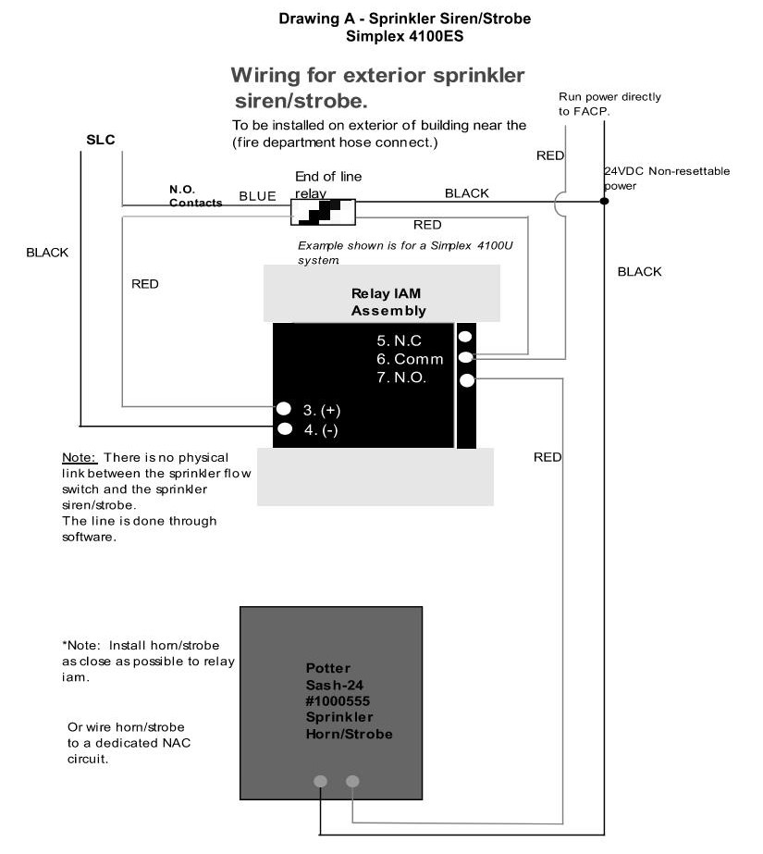
Drawing B - Equipment Control
Simplex 4100ES
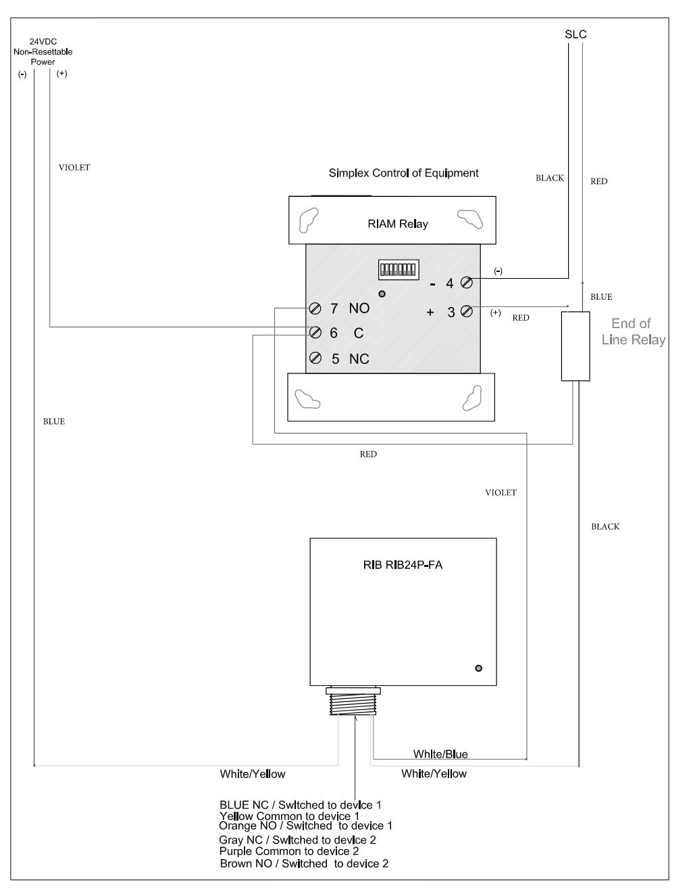

Drawing C - Damper Control
Simplex 4100ES
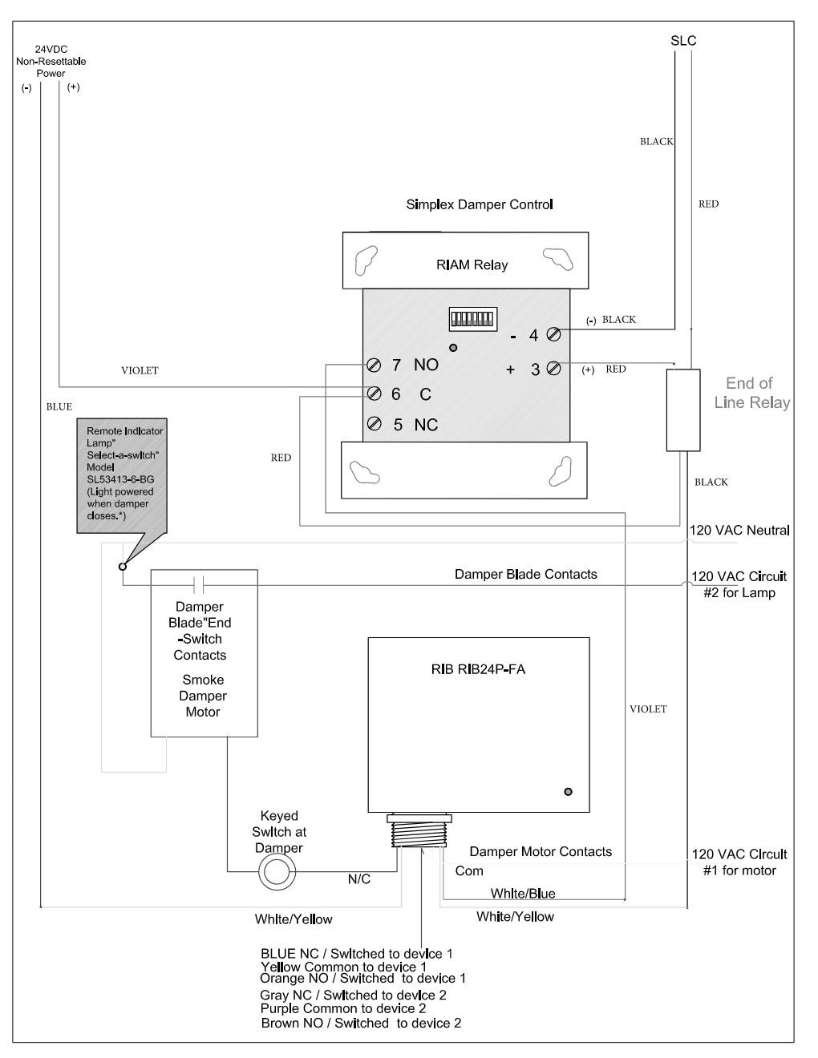

END OF SECTION

[Use next three drawings if project includes Notifier 3030 NFS, AFP System.]
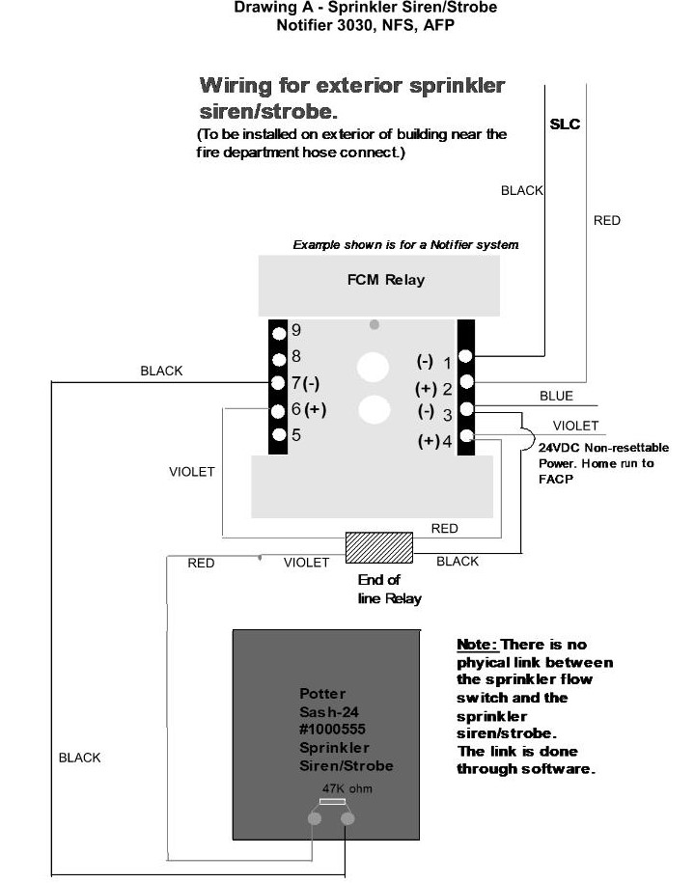
Drawing B – Equipment Control
Notifier 3030, 2020, NFS, AFP
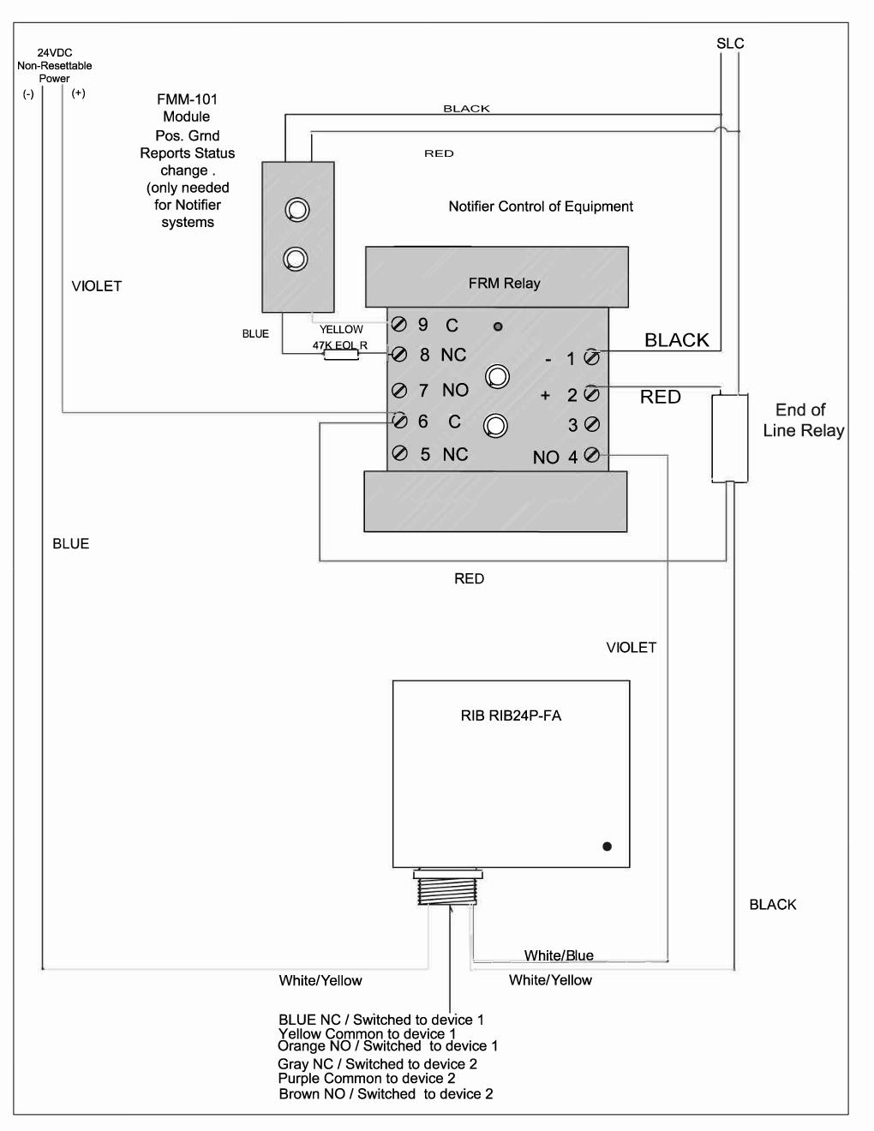
Drawing C - Damper Control
Notifier 3030, NFS, AFP
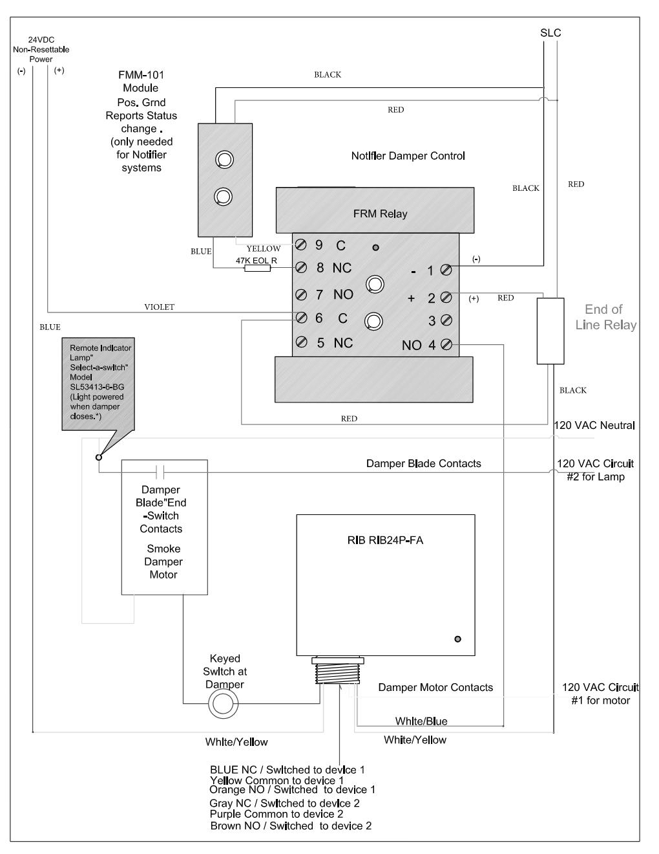

END OF SECTION

