Summary of Updates
September 2020 Editions

Updated Forms - Contractor webpage:
Contractor Early Release of Retainage Request
Subcontractor release and Waiver of Claim Rights

00 01 10 Table of Contents (formal and informal)
Updated to reflect September Editions

Cover Page (formal and informal):
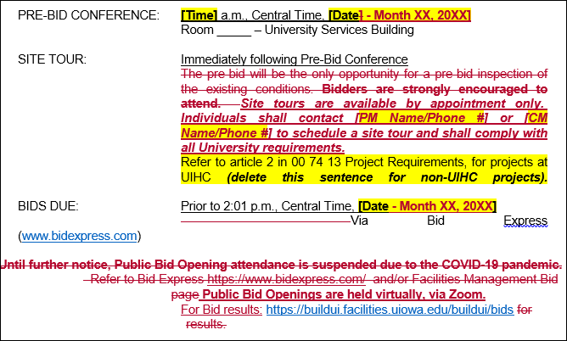

00 74 13 Project Requirements
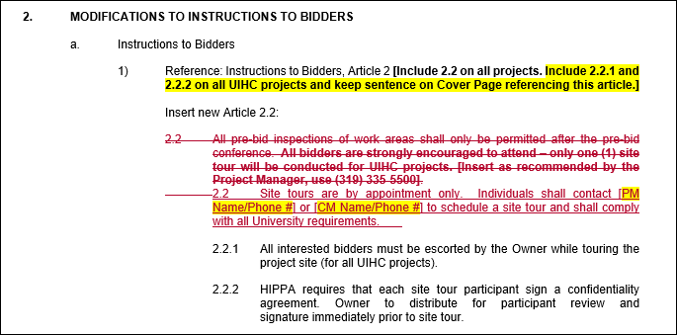
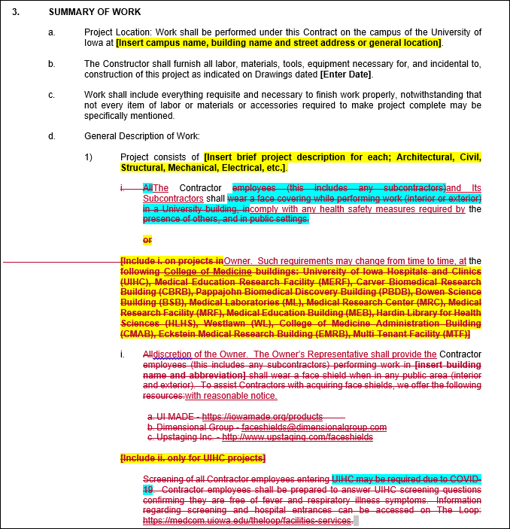
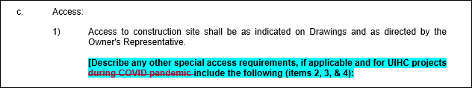
00 74 13 Project Requirements - Continued
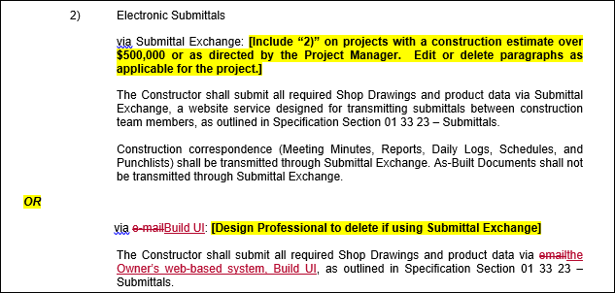
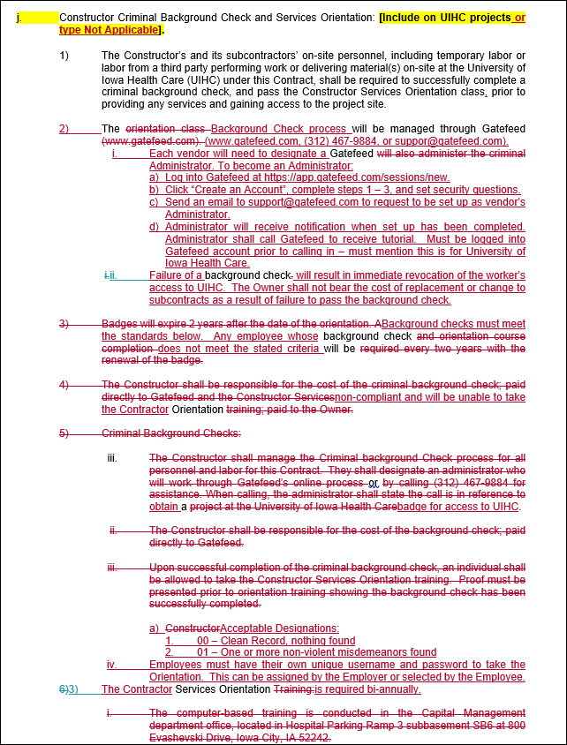
00 74 13 Project Requirements - Continued
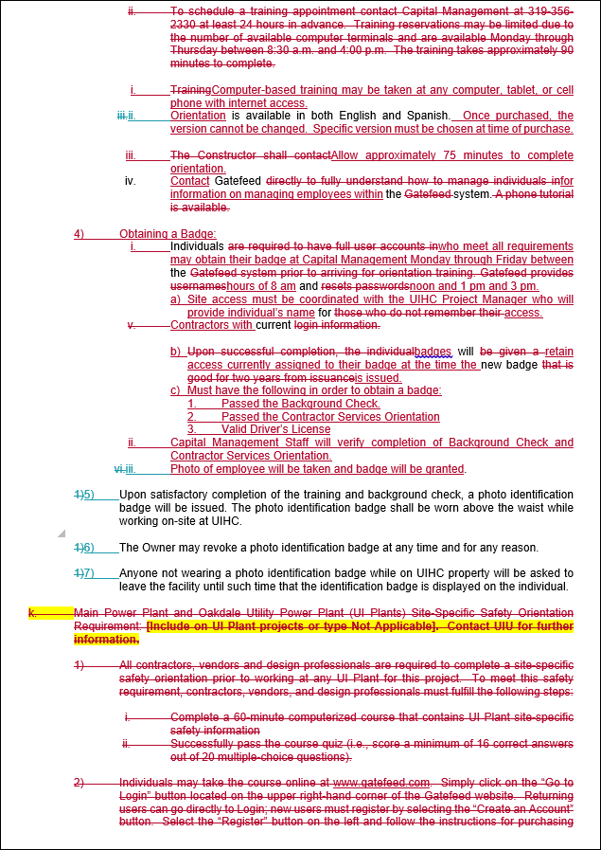

00 74 13 Project Requirements - Continued
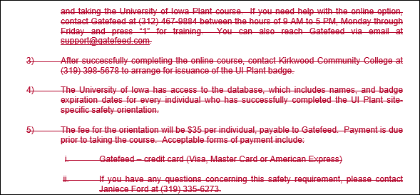

01 33 23 Submittals (formal and informal)
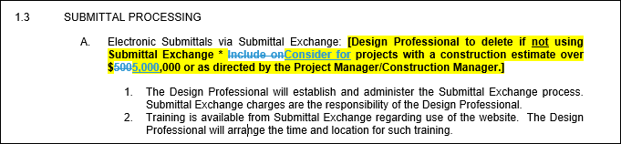
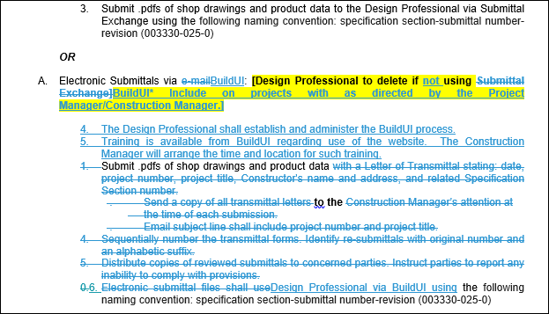

01 33 23 Submittals (formal and informal) - continued
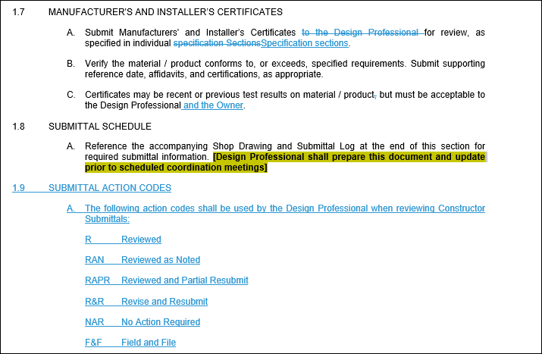

01 78 23 Operation and Maintenance Manuals (formal and informal)
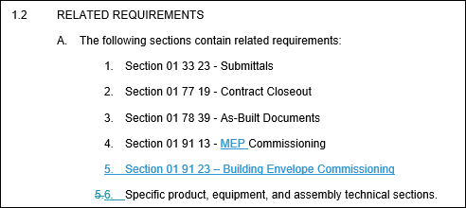
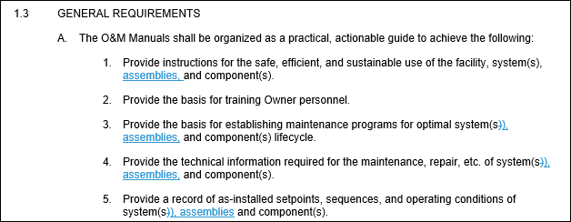
01 78 23 Operation and Maintenance Manuals (formal and informal) – continued
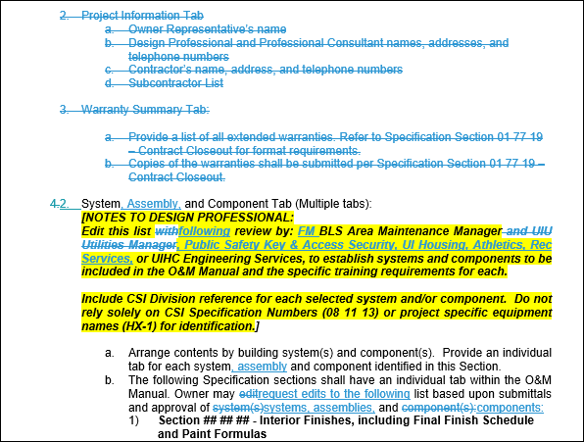
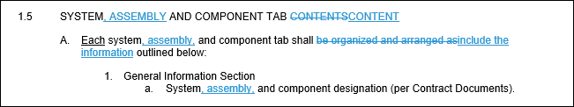
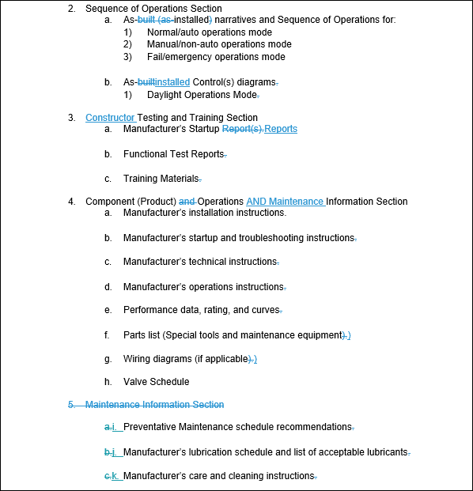
01 78 23 Operation and Maintenance Manuals (formal and informal) – continued
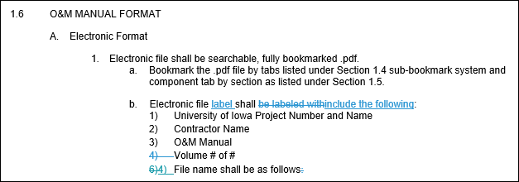
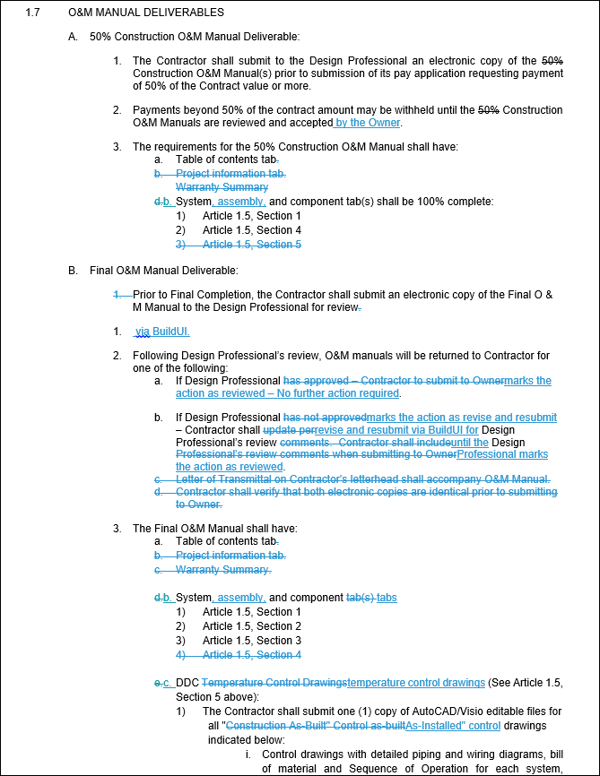

01 78 23 Operation and Maintenance Manuals (formal and informal) – continued
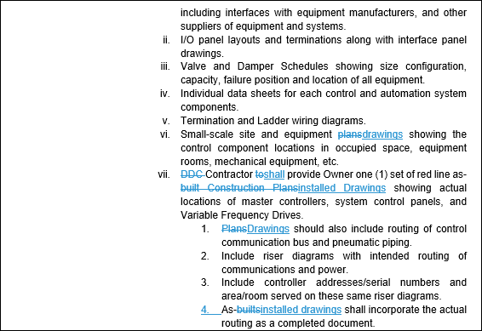
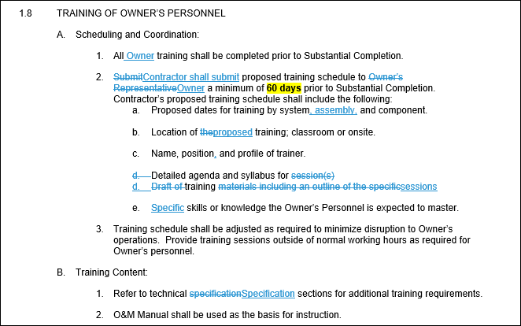
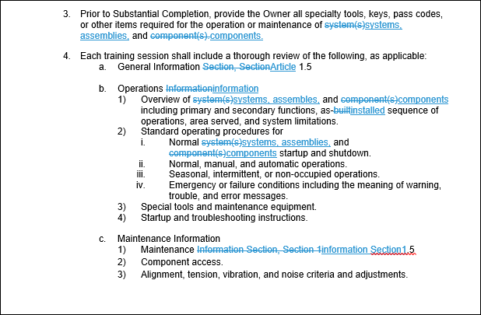
01 78 39 As-Built Documents (formal and informal)
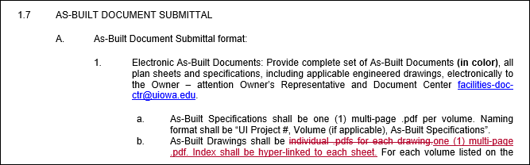

01 91 13 MEP Commissioning
Specification revised for MEP

01 91 23 Building Envelope Commissioning (BECx)
New specification

