Summary of Updates
November 2021 Editions

TABLE OF CONTENTS (Formal and Informal)
COVER PAGE (Formal)
*removed Zoom from Pre-Bid Conference
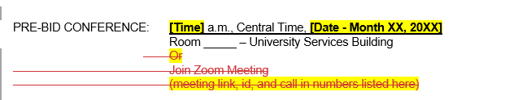
00 21 13 INSTRUCTIONS TO BIDDERS (Formal and Informal)
*removed Parking for Bid Opening and campus map
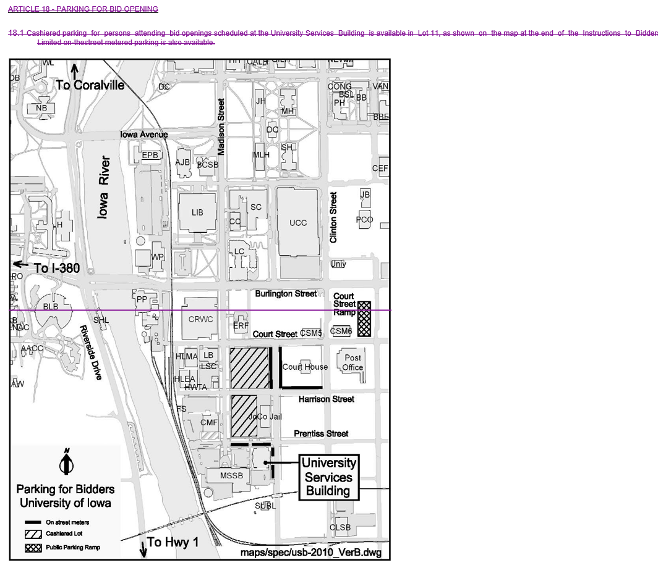

00 74 13 PROJECT REQUIREMENTS (Formal)
*added updated utility rates
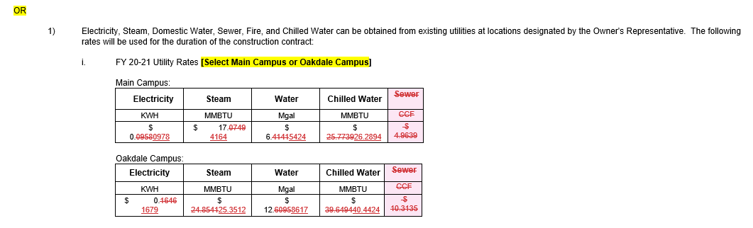

*added new Article 2.16 for Institution Requirement – “false fire alarm”
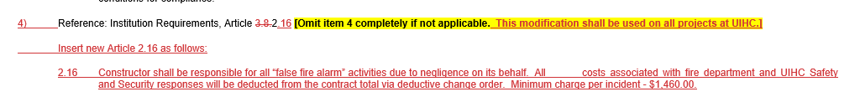

* New Document
Design Professional Evaluation of Bids template – for use by Design Professionals when preparing
Letter of Bid Evaluation. Found at: Design Professionals | Facilities Management (uiowa.edu)