Summary of Document Updates
June 2022 Editions

Informal and Formal Bid Documents:

00 01 10 Table of Contents

Updated with current edition dates

00 73 13 Institution Requirements
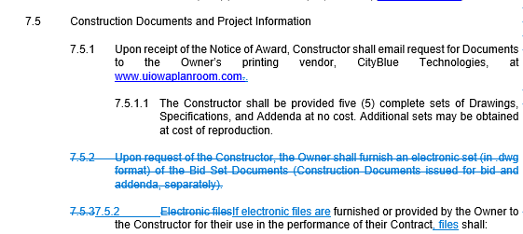

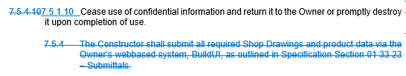

00 74 13 Project Requirements

Article for Limited Mutual Waiver of Consequential Damages has been added back into the Project Requirements.

- Limited Mutual Waiver of Consequential Damages:

- LIMITED MUTUAL WAIVER OF CONSEQUENTIAL DAMAGES. Except for damages mutually agreed upon by the Parties as liquidated damages in section 4. item d. and excluding losses covered by insurance required by the Contract Documents, the Owner and the Constructor agree to waive all claims against each other for any consequential damages that may arise out of or relate to the Agreement, except for those specific items of damages excluded from this waiver and identified below. The Owner agrees to waive damages, including but not limited to the Owner's loss of use of the Project, any rental expenses incurred, loss of income, profit or financing related to the Project, as well as the loss of business, loss of financing, loss of profits not related to this Project, loss of reputation, or insolvency. The Owner does not waive direct damages. The Constructor agrees to waive damages, including but not limited to loss of business, loss of financing, loss of profits not related to this Project, loss of bonding capacity, loss of reputation, or insolvency. The Constructor does not waive direct damages. The provisions of this section shall also apply to the termination of this Agreement and shall survive such termination. The following are specifically excluded from this waiver: [edit the following as applicable based on inclusion of Liquidated Damages or not.]

- additional Owner’s Design Professional and Professional Consultant services
- additional Owner project administration costs
- extended Builders Risk insurance premiums
- increases in project utility consumption costs
- cost of replacement or temporary facilities
- increased costs associated with Owner furnished furniture and equipment
- other items –e.g. ticket revenue, food service revenue, lost student fees, lost parking revenue etc. when not liquidated.

- The Owner and the Constructor shall require similar waivers in contracts with Subcontractors and others retained for the Project.

Article for WORKSAFE requirement has been updated to include on all projects with construction estimates of $1,500,000 or more (previously was for projects of $500,000 or more)

