Begin by logging into your BuildUI Account. (If you do not have an account, please contact ___ for assistance.)

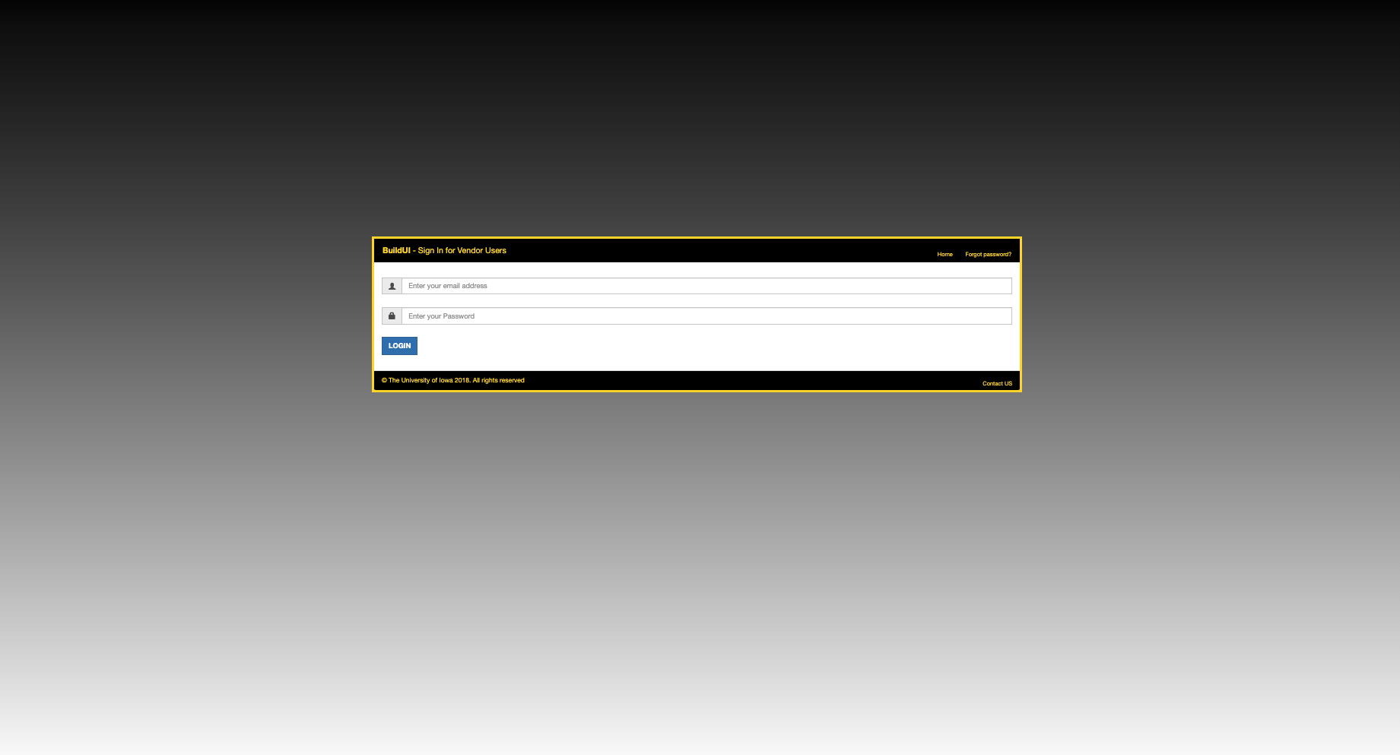

Projects that have been assigned to you will be listed on the “Home” Page. Select the project you would like to upload Project File Information.
If you do not see a project listed that you should have access to, please contact the UI PM on the project and they will add you to the project team in BuildUI.
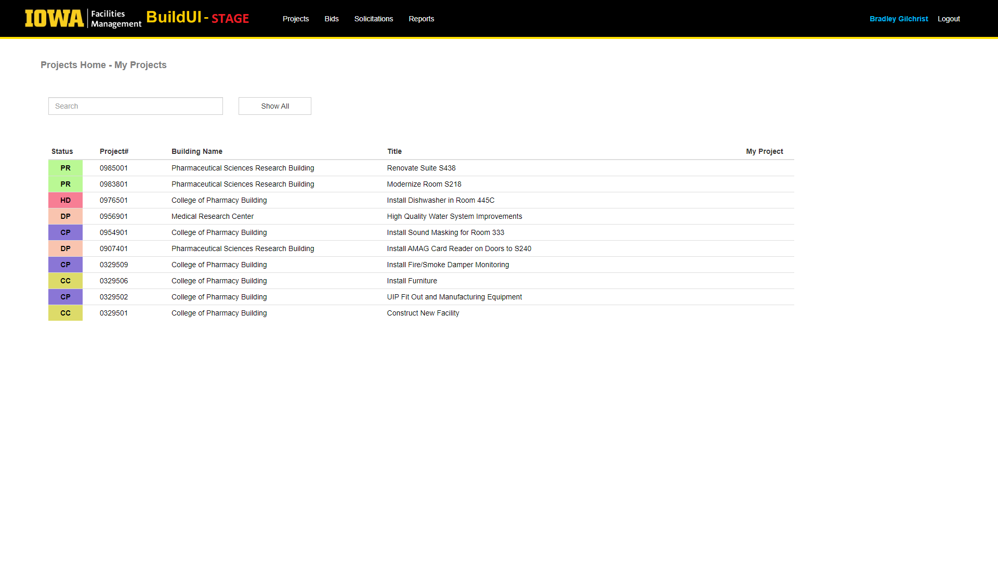

Select “Project File Information” under “Menu” on the right side of the screen. (If you do not see “Project File Information” under menu options, please reach out to your UI PM or CM to allow permissions).

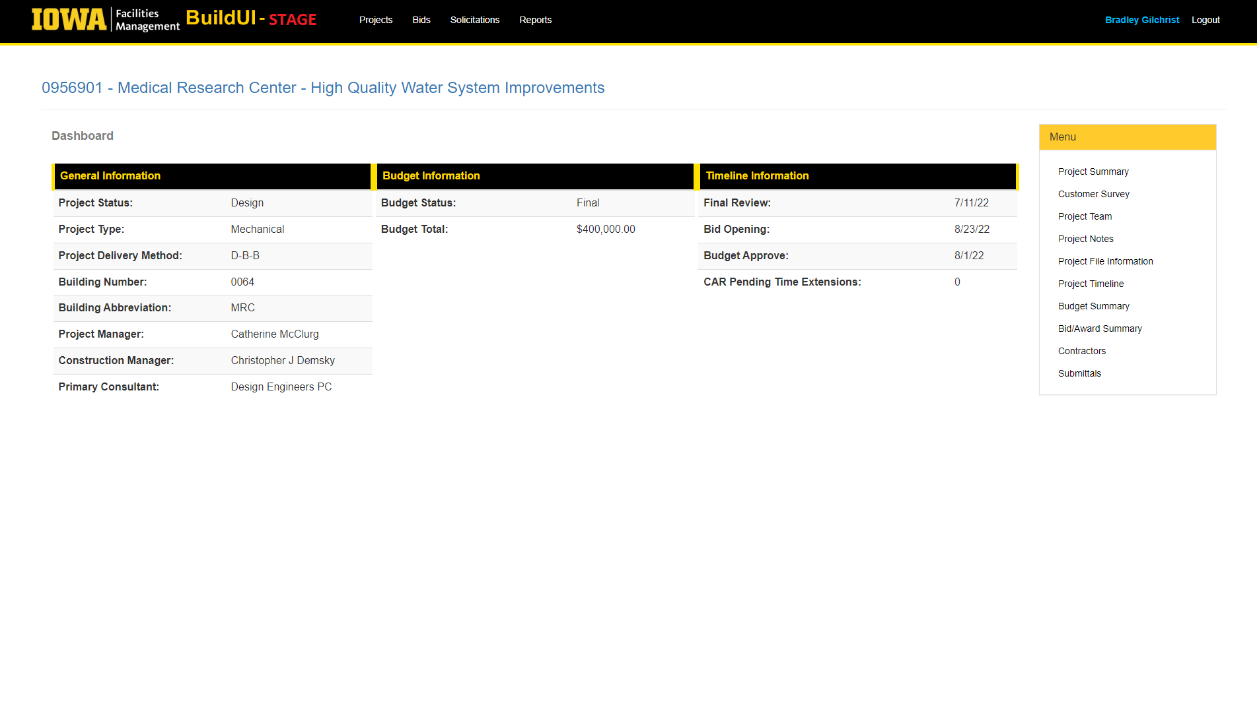

Select the category that you would like to view. Categories that have previously uploaded information will be shown in bold font (Here, Design category contains project file information). For this example we will select “Design” to view and download DD Review Meeting Minutes.
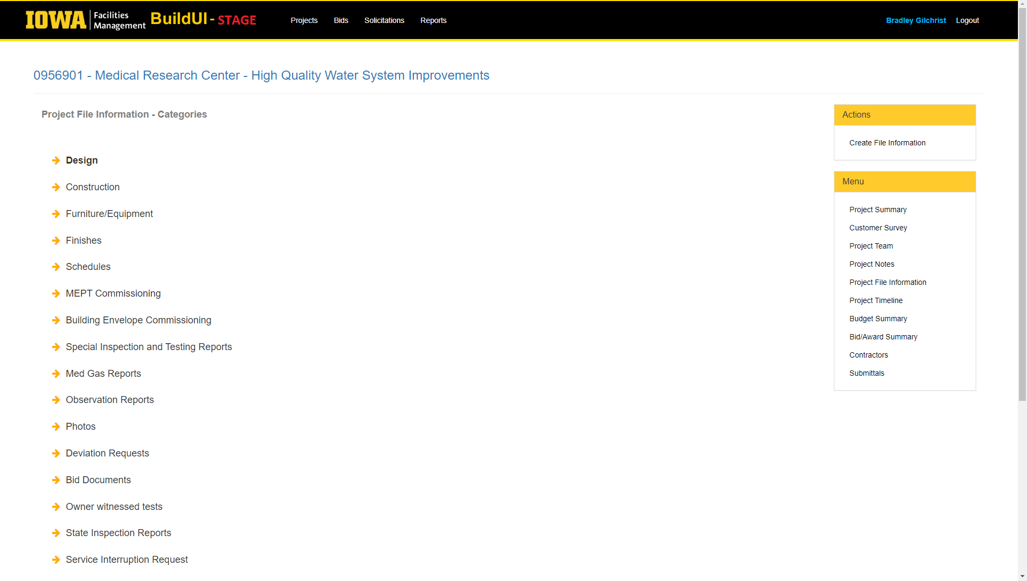

Click on the submission you wish to view. Please note: only submissions marked with a “Y” in the Primary column are considered final versions ready for distribution to the project team.

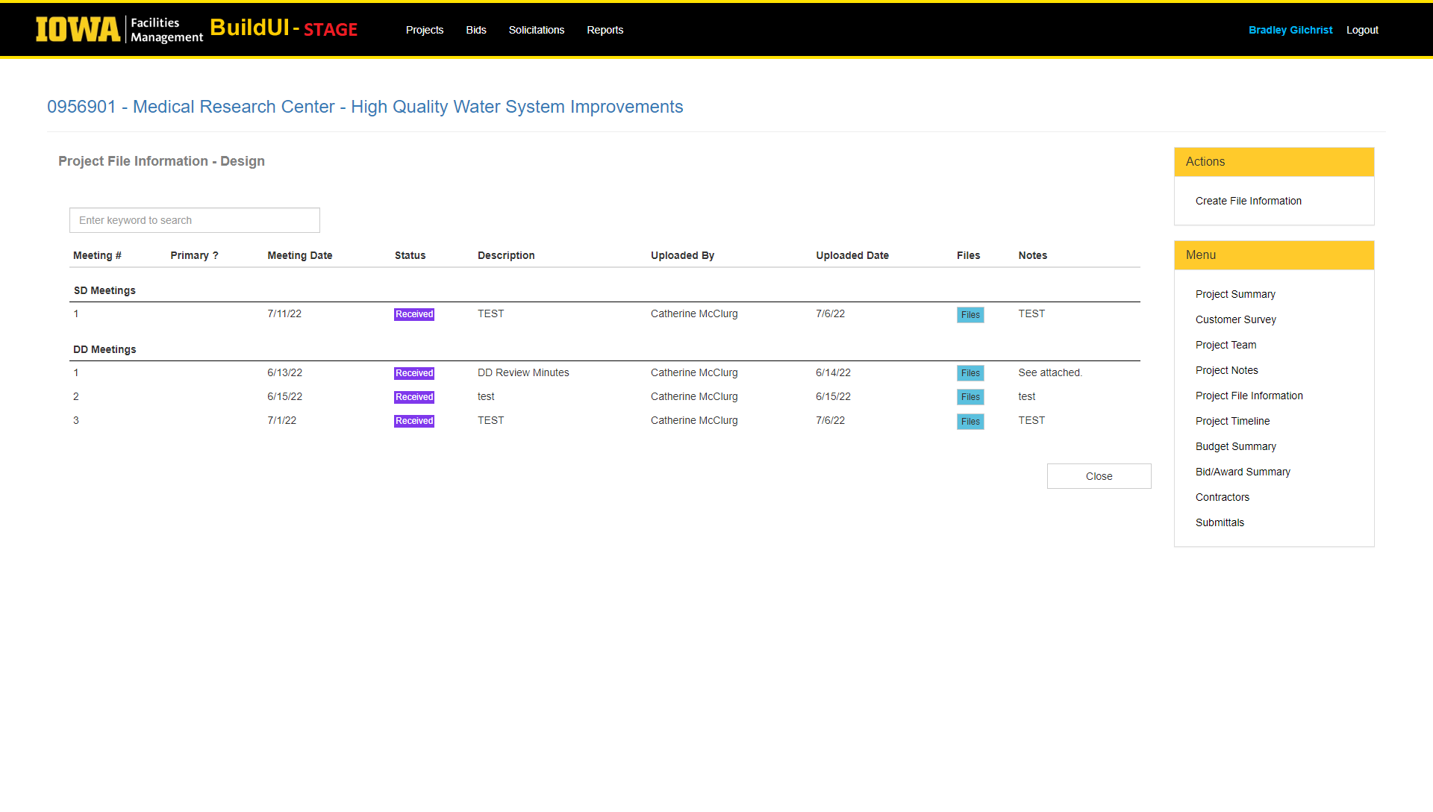

Review the information of the submission and select “Attachments” to view the applicable documents.

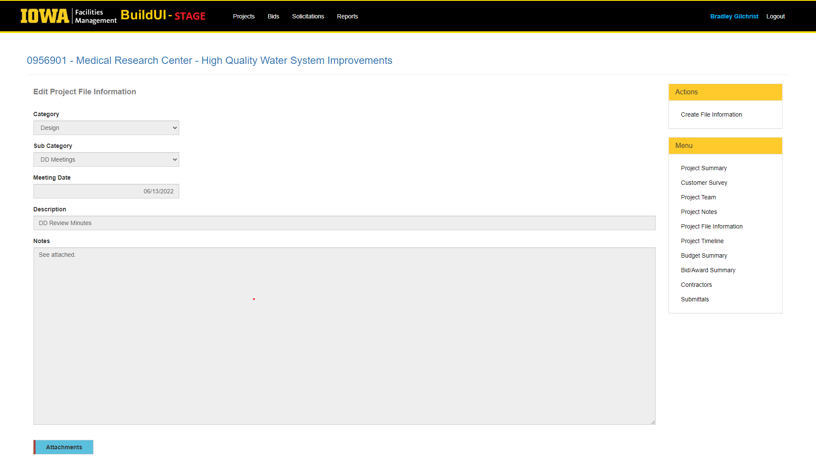

Click on the file you wish to open and/or download.

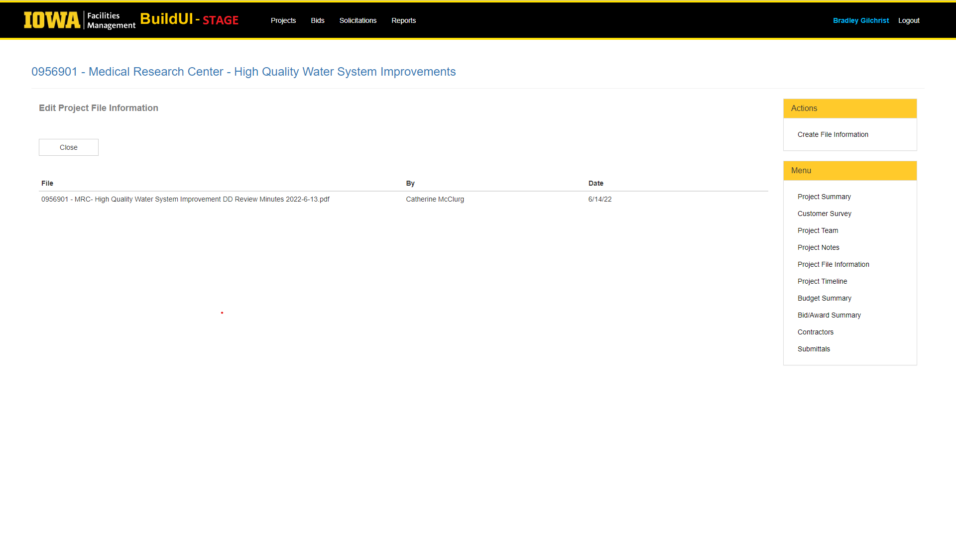

The file will automatically download in your browser or open a new window to preview before downloading. Select “close” to return to the Project File Information main screen.

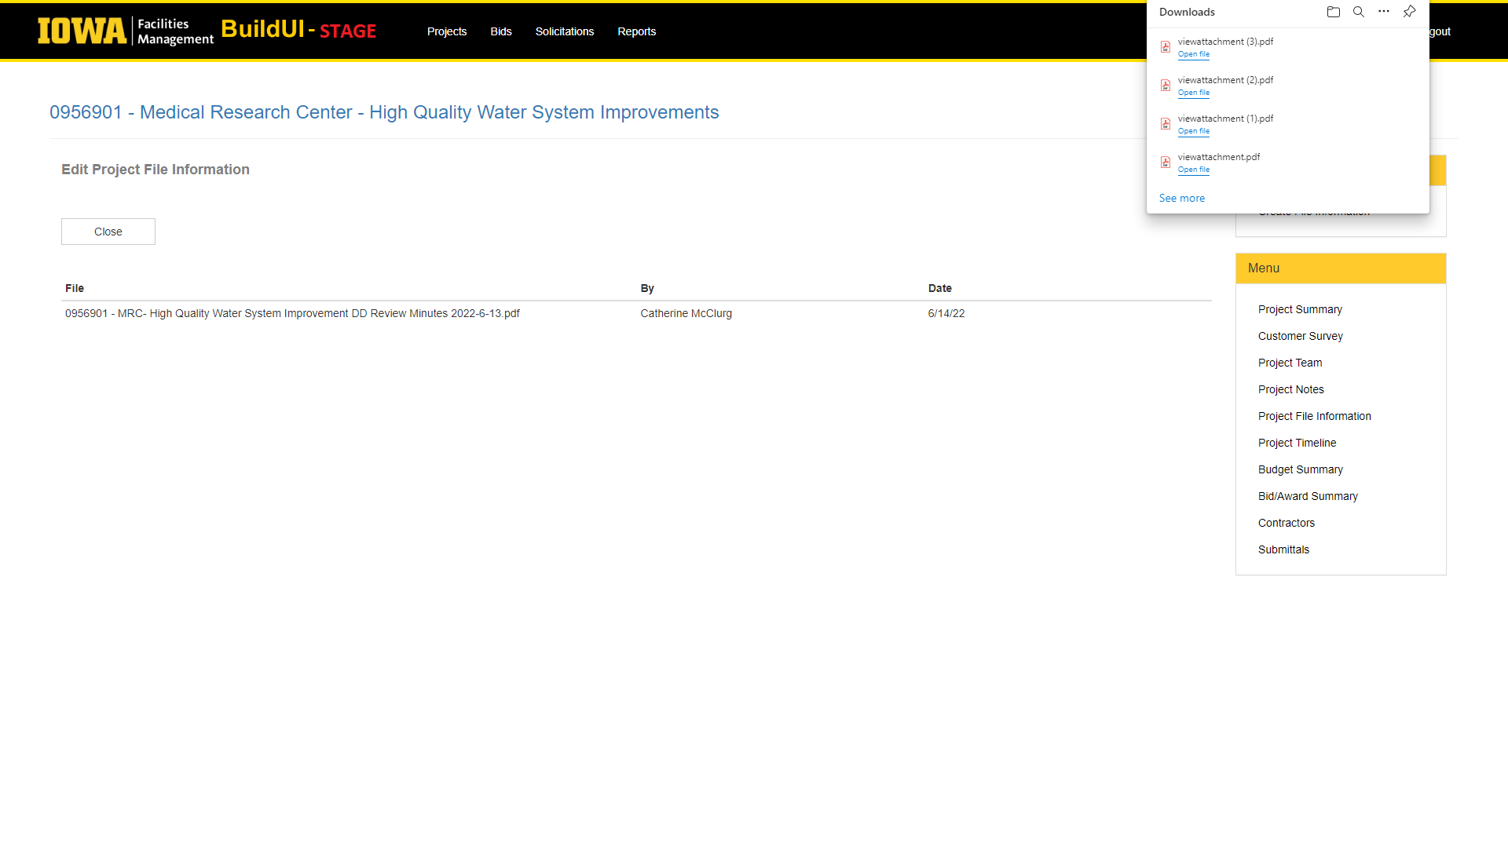
If you have any questions pertaining to this process, please contact your UI project PM or CM.

