updated 2/16/17

Schematic Design Template

(first page)
(example)
UNIVERSITY OF IOWA
Riverside Recital Hall - Remodel Space
Schematic Design

February 2017

Project Location
- Insert map.
- Label project, major roads, and landmarks.

(second page and beyond)

Site Plan
- Label project, major roads, and landmarks.
- Provide “Legend” to distinguish areas, if needed.

Exterior Renderings
- Label views (ex: looking southwest, east elevation).

Interior Renderings
- Label views (ex: lobby looking north).
- Exterior renderings not required for interior projects.

Floor Plans
- Provide “Legend” to distinguish areas.
- Existing floor plans not required.

General
- 8½” x 11” portrait layout for all text and images.
- Aerial 11 pt for all text; titles in bold.
- Two images per page maximum.
- Design narratives not required.
- Page numbers not required.
- Use the same north arrow and scale on all plans.

Example:
North

(example)
UNIVERSITY OF IOWA
Riverside Recital Hall - Remodel Space
Schematic Design

February 2017

Project Location
Project Location:
Riverside Recital Hall
405 N. Riverside Drive
Iowa City, Iowa
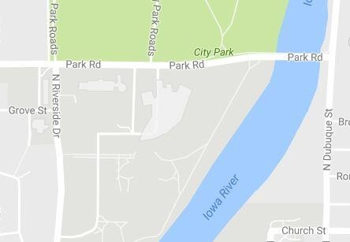
North
0’ 500’

Site Plan

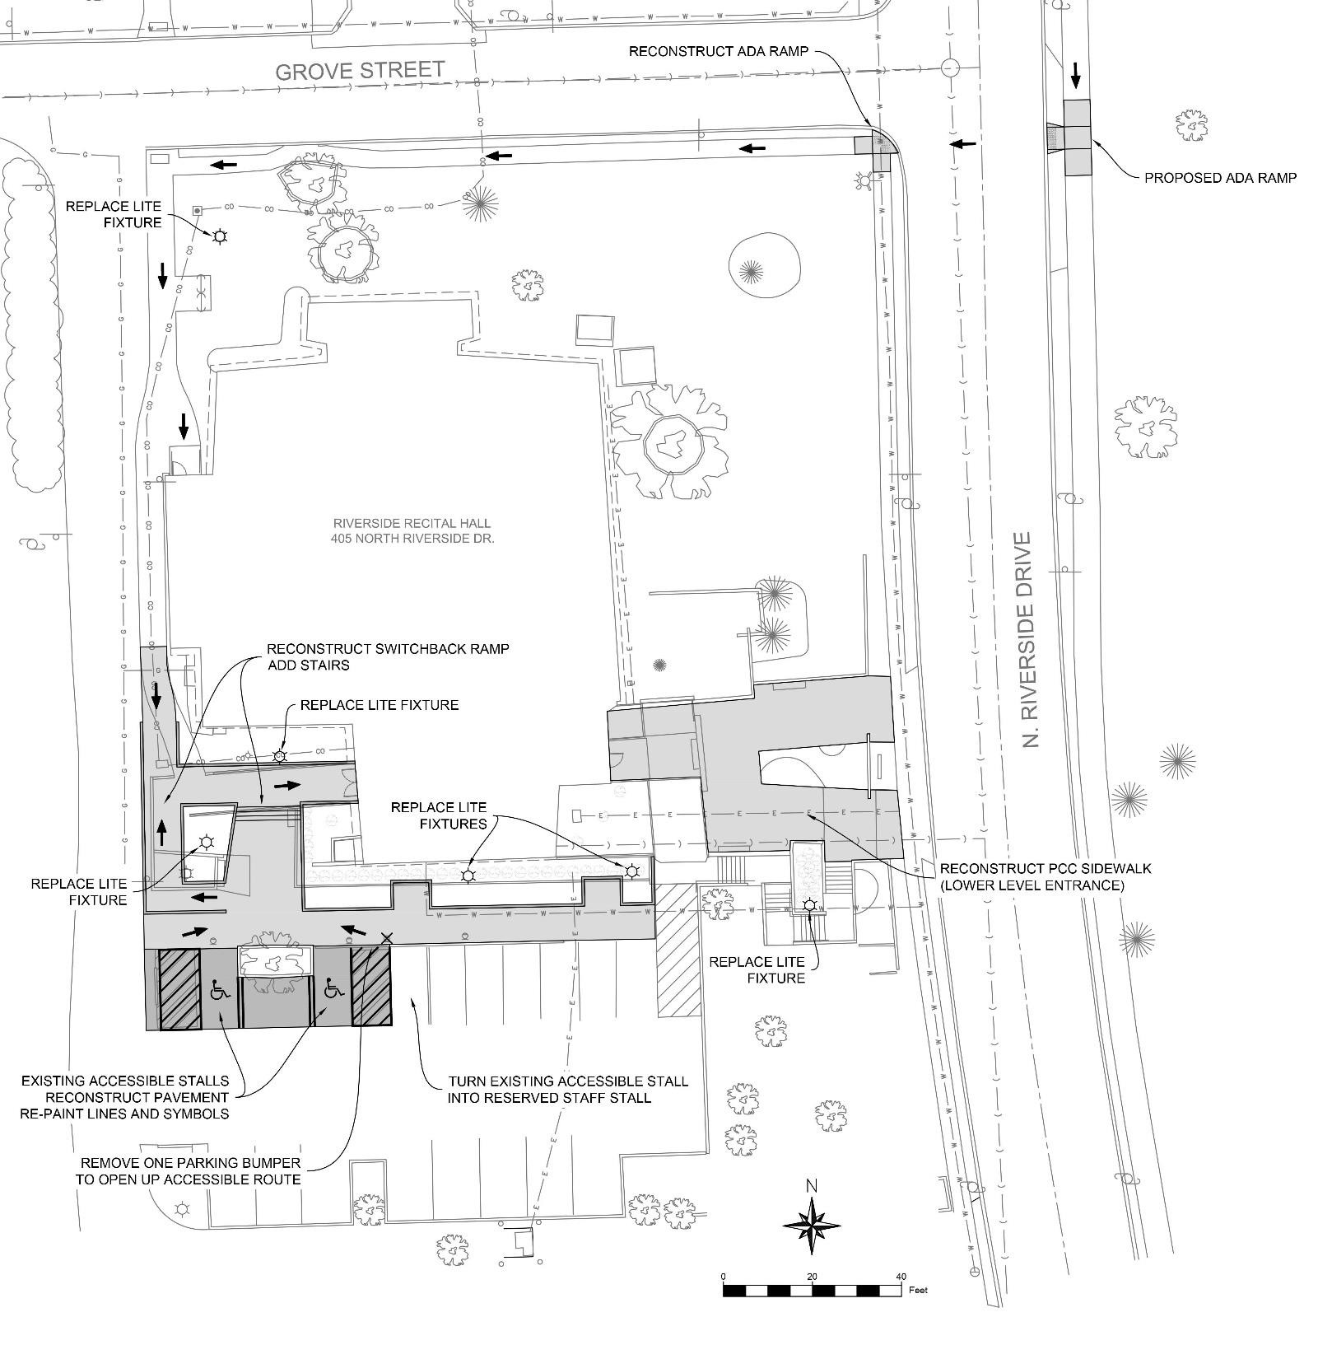
North
EXISTING BUILDING TO BE RENOVATED (NO ADDITIONS)
40'
0'
20'

Exterior Renderings

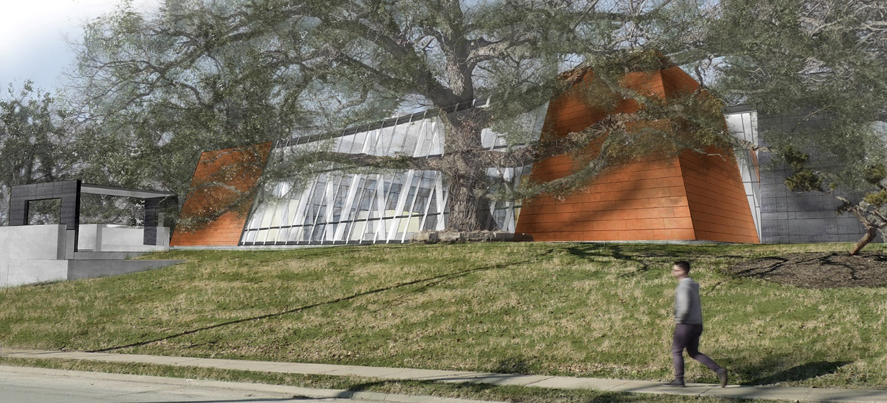
view from Riverside Drive, looking southwest

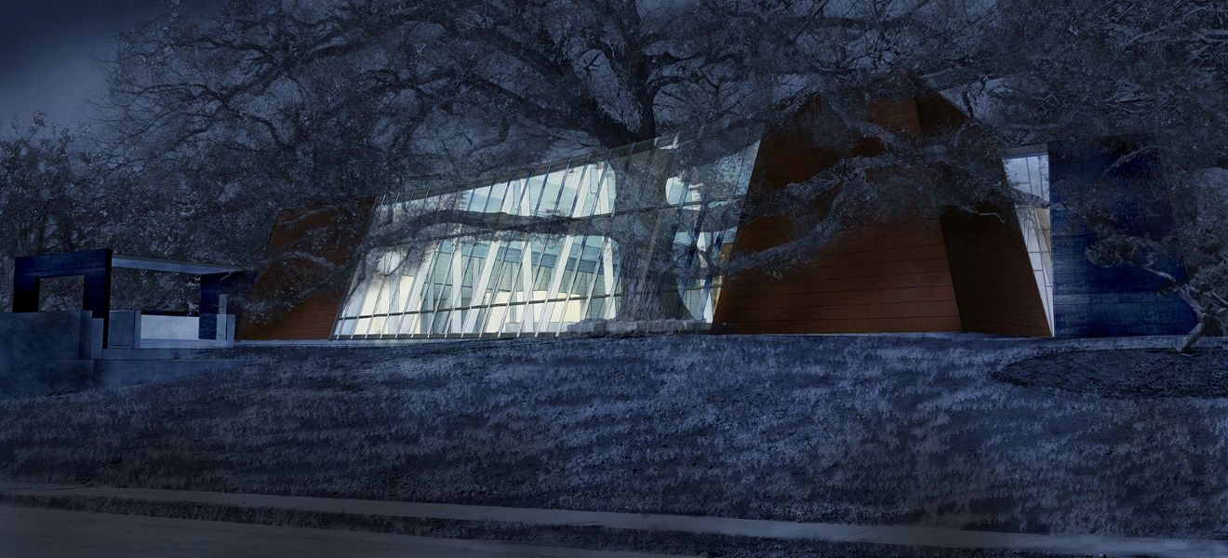
night view from Riverside Drive, looking southwest

Exterior Renderings
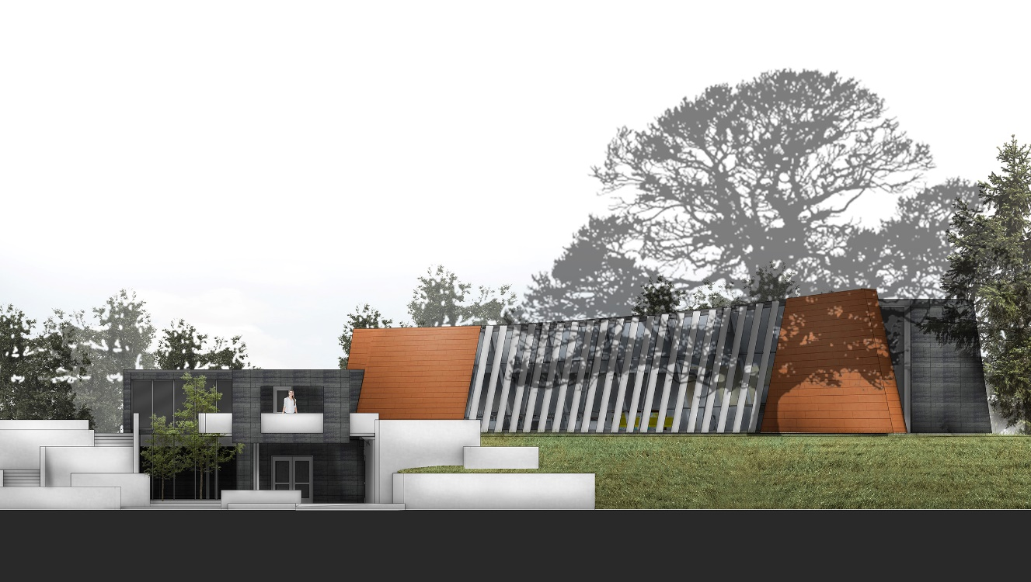
east elevation

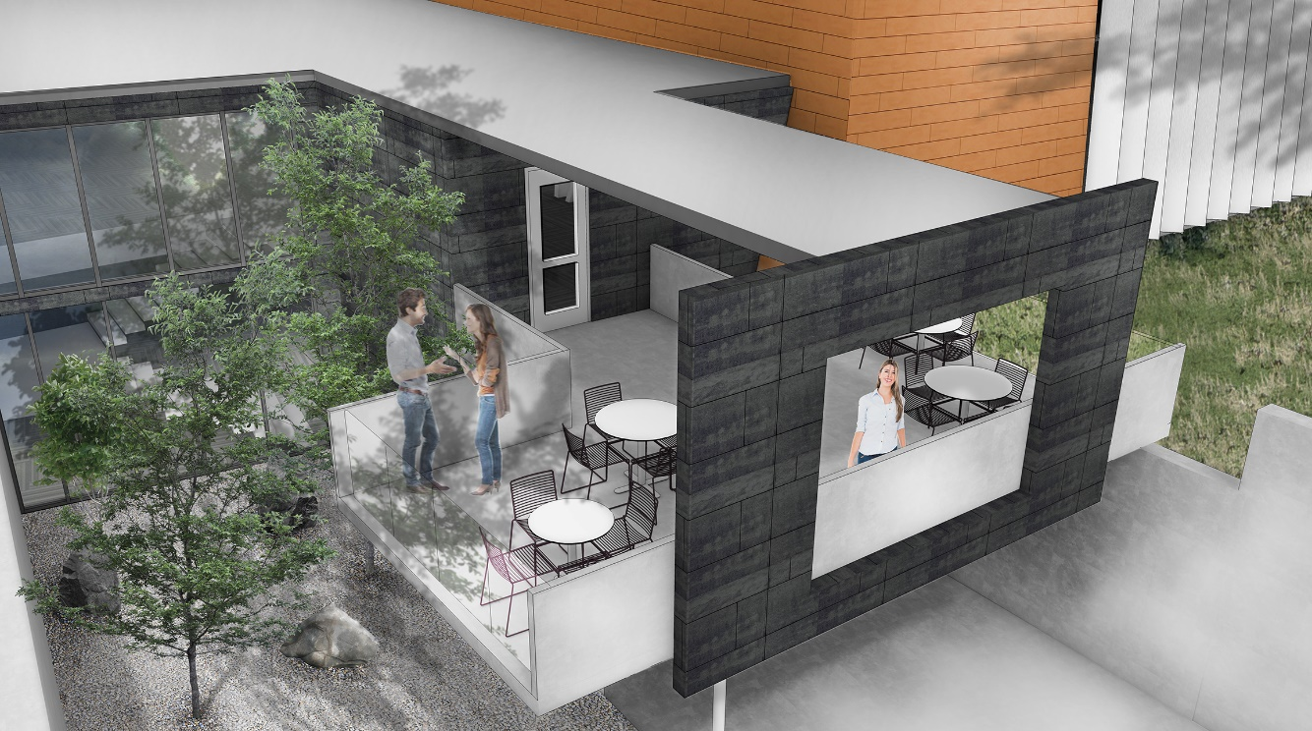
exterior seating area, southeast corner

Interior Renderings

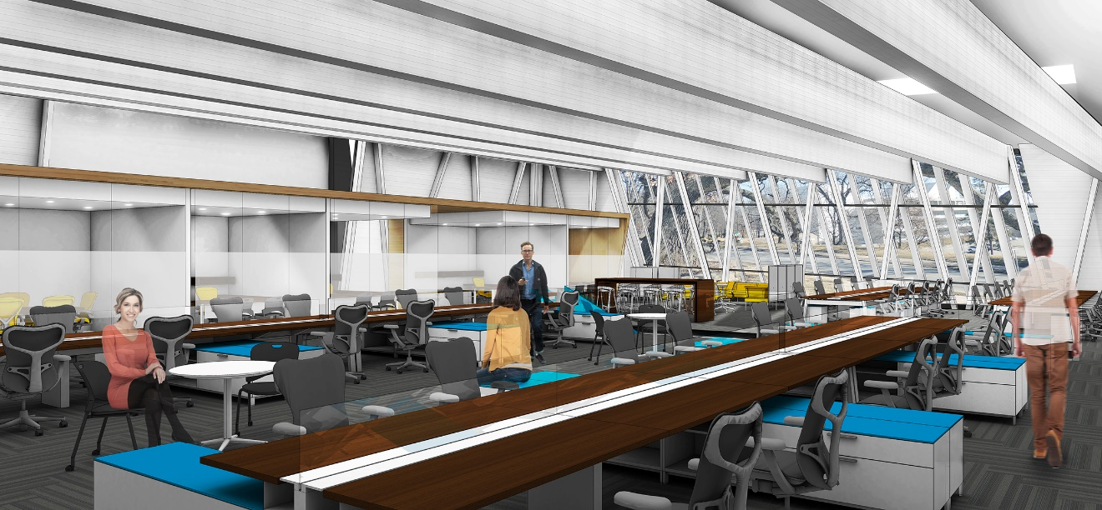
upper level – open office view looking northeast

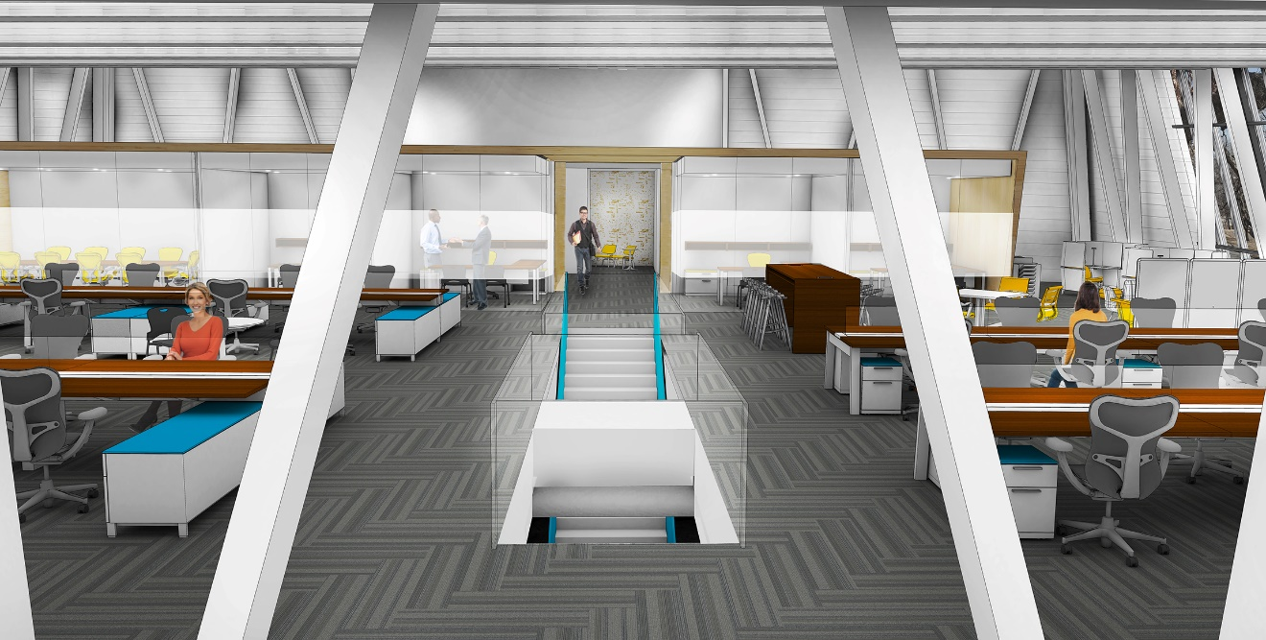
upper level – open office view looking north from south entry

Interior Renderings

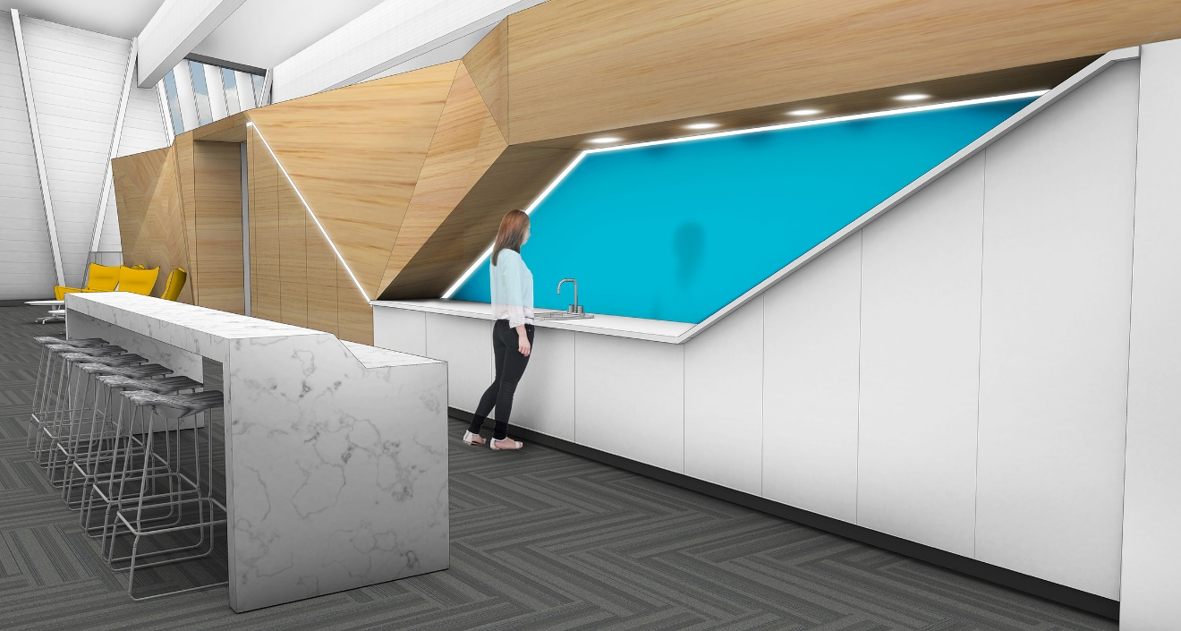
upper level – view of kitchenette looking southeast

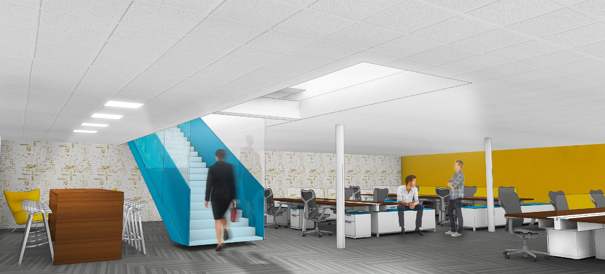
lower level – open office view looking northeast

3D Rendering

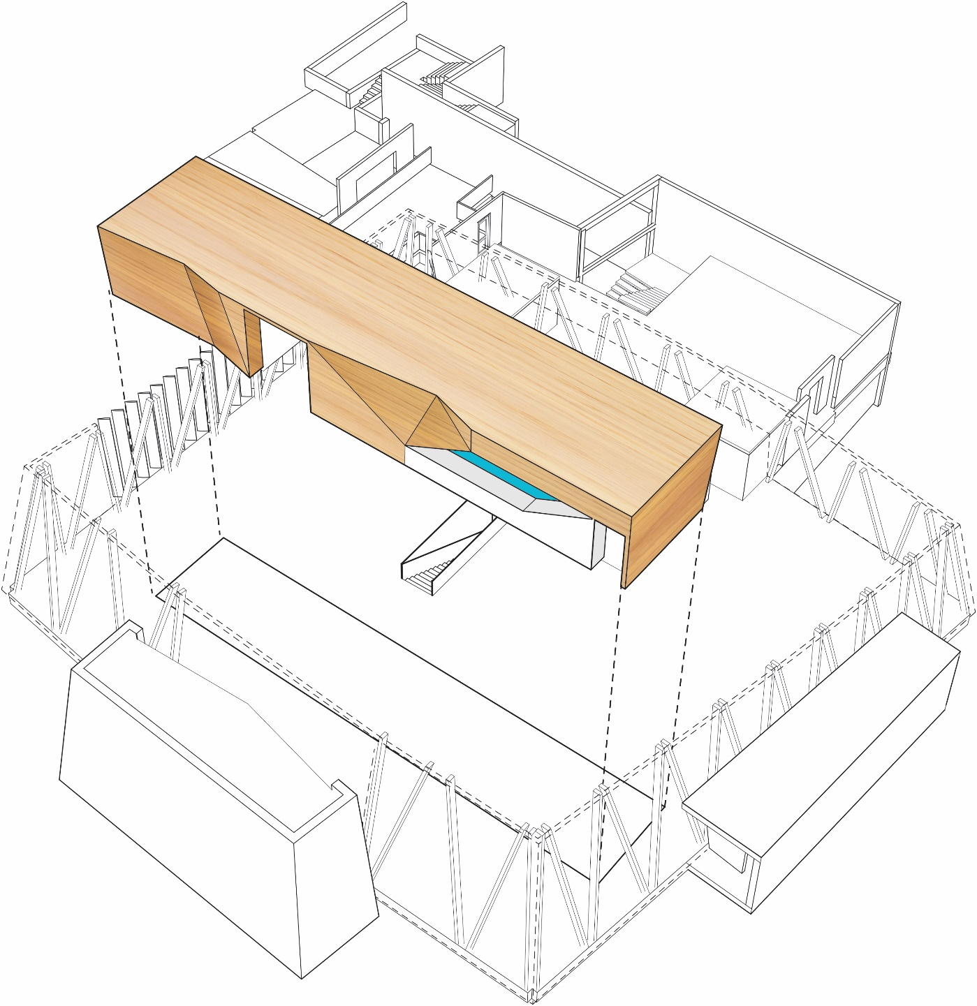

exploded axonometric diagram showing office shell concept, looking southeast

New Floor Plan

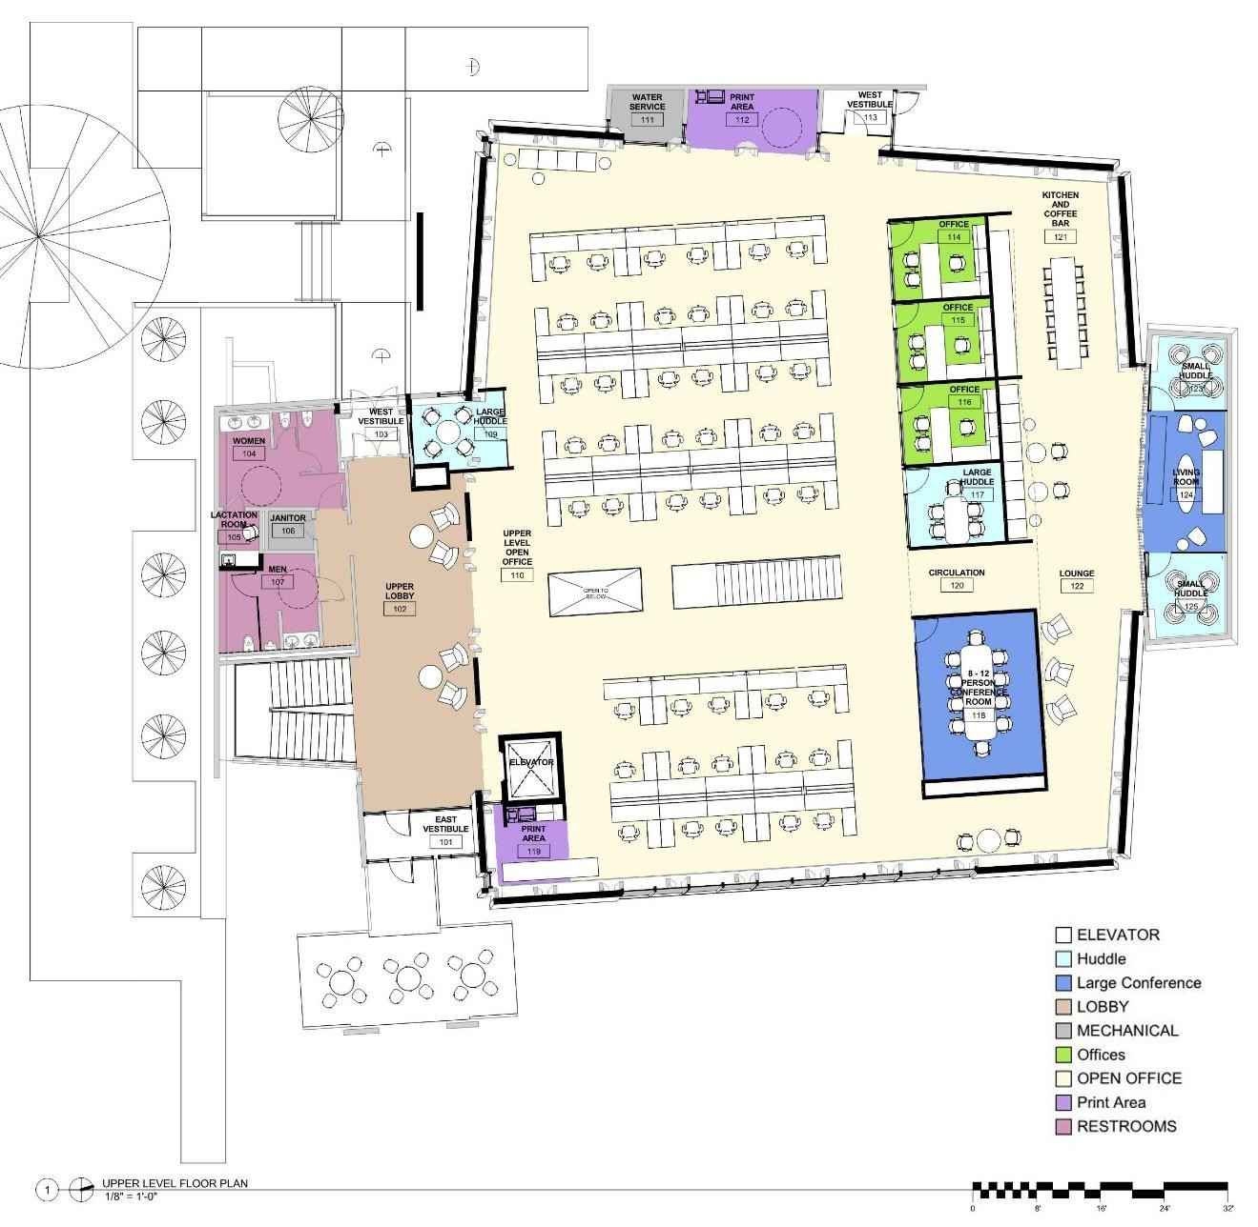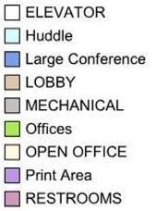
North
UPPER LEVEL FLOOR PLAN
0'
16'
32'

New Floor Plan
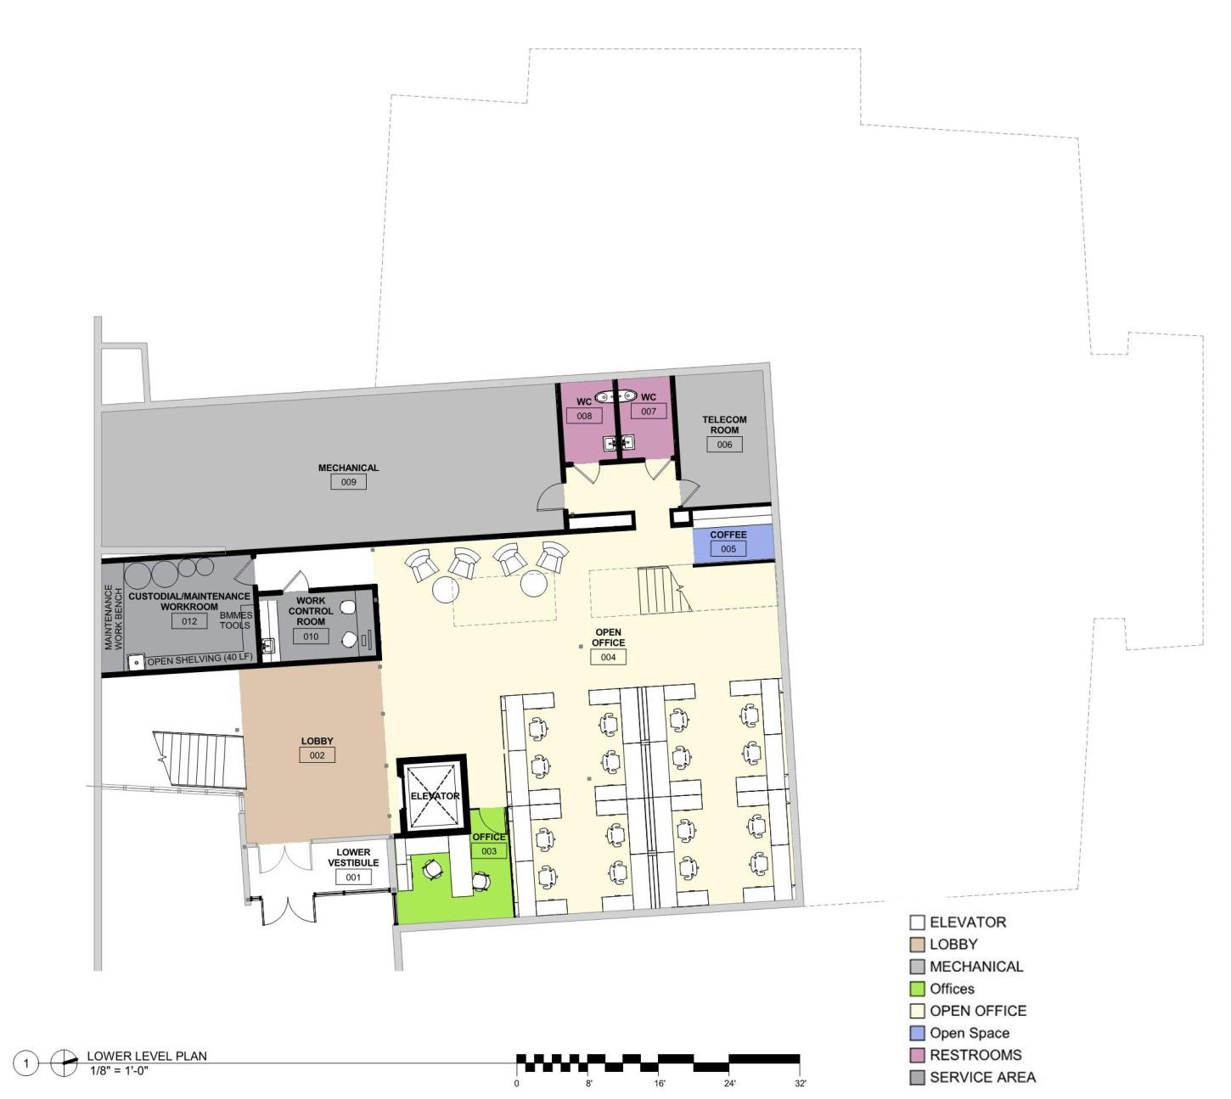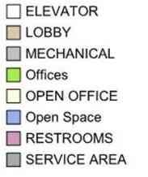
North
LOWER LEVEL FLOOR PLAN
0'
16'
32'

