Formal and Informal Bid Documents
March 2020 Editions – Summary of Changes

00 72 13 Board of Regents State of Iowa General Conditions

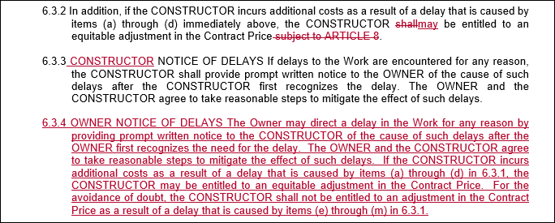

00 74 13 Project Requirements

6 USE OF SITE
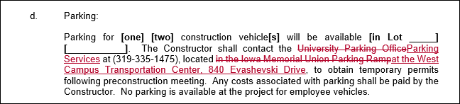

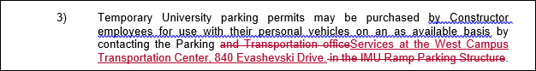

00 01 10 Table of Contents
Updated to reflect new edition dates

